MERN Stack Training / Web Full Stack / Javascript Full Stack

Duration: 140 hours

MongoDB: NoSQL Database to maintain the data

Express.js: Backend services

React.js: Frontend

Node.js: Runtime environment

Contents:

* Applications
* Fundamentals of Computer Programming
* Algorithms & Pseudocode
* Linux
* Git & Git Hub
* HTML
* CSS
* Javascript & Typescript
* React.js
* Node.js
* Express.js (REST Api’s)
* MongoDB
* DevOps

Applications: They are computer programs which can perform tasks for the users, there are 2 types of applications

1. Standalone
2. Distributed

Standalone applications: These are applications which you can used only after running in the machine

Two types

* Desktop based: This can be installed on your desktop
* Mobile based: This can be installed on your mobiles

ex: Word document, Mobile based applications

Distributed applications: These are the applications which you can access over the internet

ex: Banking services, Twitter, Facebook, Gmail, Food Ordering Systems, Shopping cart applications

How do we access distributed applications

We can access them using Browser or Client applications

Browser: It is an application which helps to enter URL and use the distributed application

Client applications: These are the applications that can internally use the URL to access distributed application

ex: Mobile applications, ATM machine programs, Swiping Machines programs

URL: Uninform Resource Locator, it is a name given to the applications to easily access it, in real time the applications use IP address & Port numbers, but users can’t remember it hence, URL will be given

Browser:

Browser is an application which helps to access any websites through URL, there are many browsers

1. Google Chrome
2. Edge
3. Mozilla
4. Opera
5. Older browsers like
   1. World wide web browser
   2. Mosaic
   3. Internet explorer

Distributed Applications:

These are the applications that can be accessed over the internet, these applications will be running in some remote machines, there are mainly 2 types of Distributed applications

1. Web applications
2. Enterprise wide applications

Web application:

A web application takes request from the browser & returns the response in the format the browser understands i.e., HTML, CSS & Javascript

Enterprise application:

These are business related applications which can serve various types of applications written in different languages.



The enterprise application return data in a format which every application can convert to their respective types, suppose Java wants to share data to C#, then Java wouldn’t share data in Java instead it shares in one common format JSON that will be converted to C# by C# applications, same can be converted to Javascript by Javascript applications, same can be converted to Python by Python applications.



How does these enterprise applications share/exchange data to other applications

Enterprise applications will have webservices (ReST based Webservices) to share the data to any applications.

REST WebServices: These are online services or API’s which are made available on the internet so that any applications can use their URLs to consume the data, usually data will be in JSON format which is converted to the format the consuming application is written in



What are the common formats the webservices can use to share the data

1. JSON (More widely used): Easy to understand & maintain hence its used widely almost 99.9% of the time
2. XML
3. TEXT
4. HTML

Web applications: These applications will have web pages, there are 2 types of web pages

1. Static web pages: These are the pages which are having same contents for all the users, it doesn’t change but its common for all the users

ex: Wikipedia

1. Dynamic web pages: These are the pages whose contents are different for different users, these pages change their contents at runtime

ex: Gmail pages, Facebook pages and so on

Technologies/Languages used to create Static & Dynamic web pages

Static pages are created with below languages

1. HTML
2. CSS
3. Javascript

Dynamic pages are created with various technologies

1. C#: ASP .NET
2. Java: Servlets & JSP
3. Python: Django
4. Javascript: React.js, Angular.js, Ember.js

How the dynamic pages are created



Here when client sends the request to the server, it sends the URL to the server, the server is going first check in the primary memory whether any instance/entity/object can handle the request if the entity is not present then server checks in some configuration file to know which is the entity to handle the URL, it loads that entity to the primary memory & it executes the code to generate response, here response will be HTML because client is browser, however it can generate different HTML response for different clients for same URL.

ex: If you login to gmail then you see different page and others see different page.

What is the language browser understands

1. HTML
2. CSS
3. Javascript

What is the language client & server uses to communicate

HTTP: Stands for Hyper Text Transfer Protocol, it is the language client & server uses to communicate, they communicate using request & response, since they use HTTP they are also called as HTTP request & HTTP response.

Architecture of HTTP request & HTTP response

HTTP Request



When client sends the request an HTTP request will be sent, the HTTP request will be divided into two sections

1. Header
2. Body

Header: It will have header properties like URL of the server resource, content type like text, json, xml and so on

Body: it will have content/data

HTTP Response



The Response will have 2 sections header & body

Header of the response will have header properties of response like content type, content length, time take to produce response, status codes like (200, 404, 405) and so on

Note: status code plays an important role for the client programs, because client programs can understand whether the request is succeeded or failed.

If status codes are in 2xx series then its success

If status codes are in 4xx series then its failed

HTTP status codes

These are some standard codes for client & servers used while communicating so that they can make decisions based on the status code

200: Ok

201: Created

404: Resource not found

401: Unauthorized access

400: Bad request

Application design patterns

Design Pattern:

It is a solution to the commonly occurring problems in application development, there are many design patterns in the IT industry which suits for certain kind of requirements, some of the most widely used design patterns are:

1. Singleton pattern
2. MVC pattern

Singleton pattern: It is a design pattern which creates one & only instance to serve some tasks, even if you try to create multiple instances it gives you single instance

ex: Task manager of an OS doesn’t create multiple copies of it, instead same copy of task manager is used

ex: Database Connections can be singleton so that multiple instances of the application can use same database connections

MVC pattern: MVC stands for Model View Controller, it is one of most widely used design pattern in many of the applications almost all the applications follow it, because it separates the roles of the code so that it will be easy to maintain and develop.

This makes application to easily adapt for the changes and development will be faster because you will have different teams for different roles like one team for only view layer, one team for only controller layer and another team for only model layer.

What type of application we will develop in Full Stack

A fullstack developer needs to know all the phases (developing, testing, deploying) of the application development, full stack deals with two types of applications

1. Front end applications
2. Back end applications



Backend applications:

These are the backend services which are available online to access from any kind of applications normally they are RESTful webservices, they will have database connectivity, business logics, data processing logics and so on.

Database logics will take care of performing operations on the database, normally these operations are called as CRUD operations(Create Retrieve Update Delete), However business logics will take care of performing business specific actions.

Business logics:

These are the logics which are performed before database logics, like

1. checking for balance before debiting the amount, else respond with insufficient amount
2. Checking for ID card validity to process the user details
3. In Facebook you need to wait for 24 hours to again delete your account if in case previously you have deleted and cancelled it

When we follow MVC architecture you will keep in business logics & database logics in model layer as below:-



We have many technologies to implement the backend services like

* Java
* C#
* Python
* Javascript (node.js & express.js)

Front End applications:

These are the applications which can be run on different devices they will have only UI’s it could be Mobile, Web Browser, Different devices like Watch, VRH, GPS devices, swiping machines, they can be developed in various technologies like

* Java for android devices
* React.js for many mobile applications
* Angular Framework
* Ember.js
* Javascript

Installing Linux

* You can install it using virtual box, it is not a base machine
* You need to get two files from the below website

<https://cdn.amazonlinux.com/os-images/2.0.20190612/>



Click on the virtualbox folder



The above highlighted is an image for Virtual box that helps us to create a virtual machine to install linux OS

Lastly you need to download & install Virtual Box software



Steps to Install Linux in base machine using virtual box

1. Firstly we need to Virtual Box
2. Secondly we need to open Virtual Box & install Linux OS

Once you login to the linux machine you will see below message as EC2 Amaxon Linux 2

The highlighted part is the location of the linux command prompt, i.e.,   
[ec2-user@amazonlin]$



Linux commands plays an important role in our course

* Git
* React & Nod.js: When you use terminals to launch react & node applications
* Deployment

Evolution Programming Languages

Computer understands Machine Level Language, when it comes to language evolution we have

1. Machine Level Language: Hard to understand
2. Assembly Level Language: Works only with certain processors
3. C: Procedure Oriented Programming Language
4. C++: Object Oriented Programming Language & Platform dependent
5. Java: Object Oriented Programming Language & Platform Independent
6. Javascript: We can use it to develop both frontend and backend applications

How to create applications

Applications are created with programs, these programs will have lot of rules in the form syntax to make compilers & machines to understand, we need to follow those rules to make the application work, else we get errors

We must able to write the code properly, but for that as a beginner we must know 3 things before writing the code

1. Algorithms
2. Flowchart
3. Pseudocode

Before writing the code / program we must know how to solve the problems, hence we have algorithms, flowcharts & pseudocode

All these three are independent of the programming languages as they are not understood by any compilers or machines, they are steps given for humans to understand what is the solution for the problem & use those steps they can write the program.

Algorithms:

* It is independent from the language
* It is a step by step procedure to solve a given problem to get the desired result
* It is not understood by computers
* It gives steps in English statements

Flowcharts:

* It is independent from the language
* It is to understand the flow of the problem solution to better understand the Algorithms
* It gives us pictorial representations of the algorithms
* It is not understood by computers

Pseudocode:

* It is independent form the language
* It mimics programming languages
* It gives us the idea what all the common programming constructs you have to use to solve the problem like conditions, loops
* It is not understood by computers

Note: There is no standard rules about how we should write Algorithms/FlowCharts/Pseudocode, we can write them however we want to understand properly

Note: Once we become good at coding, we may not need these Algorithms, Flowcharts, Pseudocode

Let us write all 3 to solve a simple problem

Problem: Find the area of a circle & print the area

Algorithms

Step1: Start

Step2: Take the radius

Step3: Take the PI

Step4: Multiply radius with radius once

Step5: Multiply PI with the result you get from Step4

Step6: Take the result you get from Step5 and store in a variable area

Step7: Print the area

Step8: Stop

Flow charts

Flow chart has some defined symbols



Flowchart for the area of circle



Pseudocode:

It mimics the programming language, the pseudocode for the area of circle

begin

read radius, area

set radius=value

calculate area = pi * radius * radius

print area;

end

Simple Activity:

Find the highest number in the two numbers

i.e., which is greater number

Write Algorithms, Flowcharts & Pseudocode for it.

Duration: 10 mins

Linux:

It is one of the popular server OS mainly used to run applications, install servers, databases and so on, most of the real-world applications are running in Linux machines, because they are faster than any GUI based OS.

User can access OS’s in 2 ways

1. Through GUI
2. Through Terminal/Command Prompt

GUI based OS are good for end users, there are many GUI OS’s like Windows, Mac OS, Fedora, Ubuntu and so on.

Terminal based OS are good for business related applications that are run inside these OS’s.

Linux follows Unix OS feature, Unix is also a terminal based OS but it is not free, however Linux is free & Open source

Open Source: You can customize as per your requirement

Unix vs Linux

Unix is licensed OS, it is used in mainframes and for installing server side resources, Linux also follows same architecture of Unix, all the commands of Linux works in Unix also and vice versa.

Linux comes in 2 flavours

1. Terminal based: Meant for hosting applications, installing servers, databases and so on, ex: Amazon Linux EC2, Solaris and etc
2. GUI based: Meant for end users who needs GUI, ex: Fedora, Ubuntu

Linux commands:

These are the commands Linux based OS understand to work with Linux, you can do all kind of operations like creating files, editing files, deleting files, renaming files, installing software’s, running programs.

List of utility commands in linux

1. cal
2. date
3. pwd
4. ls
5. ls -l
6. cat
7. rm
8. mv
9. grep

cal: Shows calendar

cal -y: Show current year calendar

cal 2015: Shows 2015 calendar

cal 05 2015: Shows May 2015 calendar

date: Shows the date



cd: It helps you to navigate from one directory to another directory

Suppose you are inside ec2-user directory and ec2-user has 2 directories

1. apps
2. hello

From [ec2-user]$ you can use

cd apps : This takes to [ec2-user/apps]$  
(or)  
cd hello: This takes to [ec2-user/hello]$

mkdir: It helps you to create directory

Suppose you want to navigate from one directory to another backward then you can use cd ..

cd ../../: This goes 2 steps backward

cd abc/xyz: This goes to xyz folder present inside abc folder which is present inside current folder

How to edit files

vi: Command used to edit files

Insert characters: You need to enter insert key to enter any characters

Exit from edit mode: You need to press Esc key & :wq

Note: You will see :wq at the bottom of the terminal

cat: It is a command to view the content of a file

rm: to remove files & folders

rm -r: to remove a non-empty folder

Ex: rm -r abc

rm -r *: This deletes all the files & folders

Grep: Global Regular Expression Print:

This is for searching the pattern in the files

grep pattern filename: This command lists all the matching pattern in the file

grep pattern filename filename: This lists all the matching pattern in the multiple files

1. Create 2 files demo.txt & test.txt
2. Edit both the files with few lines of data and also have your names in both the files and also repeat your names a few times in both the files

Ex:

Hello everyone  
This is Alex, I’m learning Linux  
I understand this is server OS  
I’m Alex, I’m understanding Linux



Here -i ignores the case while searching.

Git:

It is a centralized version controlling system, it keeps track of the project state with different version numbers these version numbers are 40 characters hexadecimal values ranging from 0 to 9 and a to f, with this 40 characters code git can recognize all the changes like what files and folders are modified, at what time its modified, who modified and so on.

Git uses following things to control the versioning of our work

1. Repository: A Git folder that keeps files & folders along with that a version controlling folder called .git , this repository is like a backup that will be available in everyone’s machine which are called as local repository, there are two types of repositories
   1. Remote repository that is maintained GIT hub
   2. Local repository that is maintained in every users computer who wants to push their work to the remote repository

Note: Every repository is a mirror of other’s repository

1. Branch: A branch is moveable pointer that tells us we are in which version of the work, by default Git gives one branch it could be main/master

Note: Most of the times you don’t work in main/master branch instead you will create your own branch i.e., feature branch.

Creating Repository

There are 2 repositories

1. Remote repository: Shared to everyone
2. Local repository: For a particular user which will be linked to remote repository

There are two ways you can create a repository

1. Create in Git hub(remote repository) and clone in your local machine(local repository)
2. Create in local machine(local repository) and then create in Git hub(remote repository) and manually link the local repository with remote repository

Note: Repository is created only once to get all the histories of the work, it is not created everytime, it will be created either only when you don’t have that repository.

Creating the Repository in Remote and Cloning it in the Local machine

1. Create the repository with a name in the GIT hub
2. Use git clone command in a directory (ensure its not under any previous repositories) it must be a directory that is not under git versioning

Note: To know you are cloning in a non git repository just type git status and it must output you are not inside a git repository, if git status shows some output like files tracked, files untracked then you are inside git repository so you must not create another repository here.

Click on new



Create a new repository by entering the name & scroll down to create



Scroll down to see create repository button & click on it, you will see the repository page as below



Next we need to clone this remote repository to the local machine to create local repository

Open Git bash in a non-git repository and use ‘git clone <<url>>”



When you hit enter



Notice that you see a folder called learning-git-0207 that is empty, navigate to it, you may see main/master both are ok



Note: There’s not history in this repository because it is a new repository

Let us create our first version, it must be in the main/master branch

Do some changes and update the remote repository

>> touch readme.txt hello.txt

>> git add .

>> git commit -m ‘initial commit’

>> git push -u origin master(or)main

You must see 2 files in the remote repository also



Edit readme.txt file and write your name in it and follow the same steps(add, commit, push) to push those changes in the remote repository

Currently you are working in main/master branch which is not advisable because it is a branch that is treated as a stable branch which will be stable in everybody’s machine.

master/main branch:

* It is treated as a original copy that needs to be same in everyone’s machine
* It is used by testers, developers, operations team to work on the project

How to list branch

>> git branch

How to create a feature branch

>> git branch branch_name

How to checkout to feature branch

>> git checkout branch_name

Once you checkout to feature branch you are completely independent from the master branch



Things done with feature branch

1. git branch issue25 (creates a new branch issue25)
2. git checkout issue25 (switches to the branch issue25)
3. Make some changes in issue25 and create a commit
4. git push -u origin issue25 (pushes the issue25 changes to the remote)
5. In Remote you can merge the pull request & safely delete issue25 in both local & remote machines
6. git pull (pulls the remote master changes to the local repository & updates the local repository automatically)



Now in Git Hub merge the pull request

After merging, you can pull the remote changes in the local master as below



You were in issue26 and switched to master, then through ls you identified only 3 files, but after git pull you got 4 files as remote master had 4 files, now the local master & remote master both are up to date.

Working with the GIT when multiple users have conflicts with the history

We can create 2 folders and in each folder the same remote repository can be cloned so that each folder can act as independent local repository like independent user.



Create 2 directories with the name dev1 & dev2



In each directory clone the same repository and navigate to each repositories



As we know that we must not work in the master branch to make any changes we need to create a feature branch and push the same to the remote

In Dev1 & Dev2 the versions are same, but now we can make changes to the same file in each directory

Create a new branch in Dev1 and edit hello.txt



We must see the pull request in the remote server i.e., Git Hub



You can click on Compare & pull request



You can decide whether you can merge or simple close the pull request



Since there’s no conflict you can merge the pull request, if in case there was a conflict you must close the pull request and let user first pull the updates from the remote & then again push

Once you merge successfully you must see the content of hello.txt in the Git hub

Note: After merge you can delete the feature branch in the remote server



Currently Dev1 didn’t see any conflict as his branch had all the versions that were available in the remote hence his branch was able to merge.

But dev2 may face conflict because his branch is not upto date

Lets see the logs of both Dev2 & Remote master



Dev2 is not having 8bc6fda…. & b458489….



If Dev2 doesn’t pull those updates & tries to push his changes to the remote then merge conflict occurs, we will see how it occurs.

Firstly create a new branch in Dev2 & edit hello.txt file and push the feature branch to remote server



In the remote server we must see the pull request from the feature branch but it can’t be merged because there is a conflict that is what even Git also says



Once you click on Compare & pull request we will see merge conflict error



You will see can’t automatically merge, however you need to click on Create pull request & close the pull request so that the user who pushed this feature branch must pull the remote updates to his local repository and then he must push the feature branch.

Click on Create pull request



Click on close pull request

You can see branch is not merged and you must able to delete the feature branch.

Why there was a conflict and what needs to be done?



Firstly we need to checkout to local master & update the local master branch so that it will have the same versions of what remote master has then you can checkout to feature branch and merge the local master with feature branch



Once you use ‘git pull’ there was an automatic merge



However the feature branch dev2-edit-hello is not up to date, we can see that using git log again in the feature branch



The remote has some versions which are not there in the feature branch, however local master is up to date

You can merge feature branch with local master since feature branch is not up to date with the local master you will still get merge conflict hence we must resolve it first with a new commit that will have all the missing versions of master branch in the feature branch.



Note: ‘git merge master’ will merge the master branch history with dev2-edit-hello branch, it would’ve worked if feature branch was having same histories of local master since its missing we get the conflict error, the dev2-edit-hello|MERGING needs be resolved.

vi hello.txt: Since there is a conflict in the hello.txt it shows in the log



Here both Dev1 & Dev2 contents are merged and its in conflict you need to edit as per the requirement and create a new commit so that the new commit will have all the versions of the missing histories in the feature branch.

You can remove all the invalid contents & keep only valid contents



Then you can commit this change so that it will merge master branch & feature branch that will have all the missing histories in the feature branch.



Here the master had some commits & feature branch had some commits which were in merge conflict that was manually resolved and created a new commit.



Since the feature branch is not missing b4584… & 8bc6fd… from the master branch it can be merge in the remote server without any problem.

Since we have pushed the feature branch in the remote we must see pull request

We can merge without any problem.



Earlier it made problem, but now there’s no problem, we can merge it successfully and delete the branch.



We are seeing the merge content of feature branch of Developer2 in the remote master, but there’s still something we need to do in both the developers machine.

Both the developers are still missing some commits compare to remote master.



In both the developers console we switched to master & used git pull so that it gets all the changes from the remote master that is up to date.

Note; Earlier both the local master was not having up to date changes of their remote master as the changes were done in the feature branch not in the local master branch

Git Organization:

It is a feature that makes multiple people to work in a team so that they can access the same repository to perform git operations like push, pull, merge, clone etc.

* As a member you can clone the project & work on it and update the remote repository

Activity:

* Clone the repository
* Create a feature branch and mention your name in the README.MD file
* Push the feature branch to the remote repository
* Admin (Kishor) will merge your branch

Summary of GIT:

* Git: It is distributed version controlling system
* Git Hub: It is an online Git repository website to store the remote repositories
* Git Stages: Working area, Staging area, Commit
* Git commands: git add, git commit, git push, git pull, git merge, git status, git log
* Git bash: A terminal to enter git commands
* Git Organization: It is a feature that helps you to work in a team so that group of people can collaborate their work in a single repository

HTML

Software’s required

* VSCode editor from <https://code.visualstudio.com/download>

Note: You can download the zip file & unzip it and use the application without installing

HTML: HTML stands for Hyper Text Markup Language, it is used to develop websites i.e., contents for your websites.

HTML is main language every browser understands, it understands other technologies as well like CSS & Javascript.

HTML has tags to render the contents, these tags are predefined which every browser understands, below are some useful tags

html, body, h1, h2, h3, h4, h5, h6, p, i, u, table, form, ol, ul, input, select, div, canvas, sup, sub, hr, br, img, link, script, …

HTML headings

There are 6 header tags to create heading with different size, they are h1, h2, h3, h4, h5, h6



Output:



Creating Images

You can add images using <img> tag it has attributes like src, width & height that gives information about the image

<img src = “url” width = “number” height = “number />

Note: <img> doesn’t need any closing with separate tag, it can be closed with the same tag as it is self closing tag



Output:



Entities: These are some special symbols that HTML can show in the browser, some have names & some have numbers

Output:



HTML Lists

HTML provides two types of lists to list the data

1. Ordered: This will have numbers
2. Unordered: This will not have numbers instead they will have bullets

Tag for ordered is <ol>

Tag for unordered is <ul>

<li> is the tag used to list the data, it can be inside <ol> or <ul>

ol stands for ordered list

ul stands for un-ordered list

li stands for list item or list index



Output:



HTML tables

HTML provides <table> tag to create tables and it uses some tags to create rows & columns

<tr>: It is called as table row, used to create rows

<th>: It is called as table heading, used to create columns for main row i.e., 1st row

<td>: It is called as table data, used to create columns for the rows

apart from these tags, you have <thead> & <tbody> they are used to create table headings & table body



Output:



HTML Forms

It helps us to enter data and submit to the backend application, in HTML you can only create form controls but backend code is written with some programming languages like Java, C#, Node.js and so on, so we must only create forms and enter the data for the time being.

<form>: It embeds different controls like input box, password box, radio button, checkbox, button, drop down and etc.

<form action = “url”>: The action is an extra attribute that can submit the data to the backend, but currently we don’t have any backend so we can just enter ‘#’, the ‘#’ is a symbol used to stay in the same page

<form action = “#” method = “post”>:

Whenever you submit the form, the data inside the form goes to backend in two ways

1. In the URL of the request: This is when method = “GET”
2. In the Body of the request: This is when method = “POST”

What happens if the data goes in the URL: In that case the data will be shown in the URL of the browser, it means it will be visible

What happens if the data goes in the BODY: In that case the data wouldn’t be visible in the browser URL



Note: If in case <form> doesn’t use method attribute then the form submits the data using method = “GET”, hence you better use method = “POST” explicitly.

<input type = “text” name = “un”>

Here <input> creates an input box & type = “text” creates an input box that allows you to enter text, name = ‘un’ is the placeholder to store the value what user enters, so that backend programs can read(un) to get the value of un



Creating a simple login form



Output:



Other types of input controls like

radio, checkbox, dropdown, date etc.



Output:



If you look at the above form its not properly aligned however with HTML itself you can align the form so that each element comes in a defined alignment, for that we can create a form & inside that all of its elements can be written in a table, but it must not have border.



HTML 5 is a new feature that provides media tags

Media tags help you to include audio’s & video’s in your document

<audio>: To load the audio

<video>: To load the video

These tags also have some attributes like width, height to reserve the space for the media, it also have controls attributes to control the media

How to use audio & video

For Audio: You can use <audio> tag inside that <source> tag is used to mention the location of the audio

<audio controls = “controls”>  
 <source src = “location” type = “audio/mp3”></source>  
</audio>

For Video: You can use <video> tag inside that <source> tag is used to mention the location of the video, since you need to show the content of the video you can reserve the space to it with width & height

<video controls = “controls” width = “100” height = “100”>  
 <source src = “location” type = “video/mp4”></source>  
</video>

Note: audio/mp3 & video/mp3 are MIME types, they are the extension of audio & video, MIME stands for Multipurpose Internet Mail Extension

Current I have a beat it.mp3 and intro.mp4 files which are audio & video that can be loaded using <audio> & <video> tags, since these files are present inside medias folder that is inside the folder that has HTML files, we can give <source> of src value as “media/beat it.mp3” and “media/intro.mp4”





Output:

You must able to load audio’s & videos’ in the document

Note: For Youtube videos you need some javascript code to be used, we can figure out that while discussing Javascript

HTML 5 provided some more features on the forms like

1. placeholder: Gives hint in the control about what to enter
2. range: Gives you a scrollbar,
3. Email: It is a type for an <input> so that you need to enter valid email
4. progress: Gives you a progress bar
5. canvas element: Used to create 2D drawings
6. video & audio: Used to load audio’s & video’s
7. date, email, number: Used to create input box for various types
8. sessonStorage & localStorage: These are used to store some data in the browser

Note: Some of the HTML 5 features need Javascript help to work, like range, progress, sessionStorage, localStorage

Different types of input in HTML5



Output:



Other HTML5 features

HTML5 provided some container tags that can include other HTML elements, these container tags are mainly to recognize the document layout

1. <header>
2. <footer>
3. <section>
4. <nav>
5. <article>

These tags are provided to allow web developers to use them when they want to layout the document.

Note: These container tags works only if you use CSS

What are container tags?

These are the tags that can have other HTML elements, before HTML5 there was only <div> that was acting as a container tag, web developers used to layout the same <div> for heading, footer, navigation in the document.

i.e.,

They were adding CSS to the <div> to layout the document



Here the same <div> is used to layout the document, but CSS is must to layout, the reason you should use <div> is it’s a container tag, inside it you can have any html elements, all the elements belonging to the <div> would get same CSS effect what you provide.

Since HTML thought of avoiding confusion with the <div> they released different tags to layout the document with a proper meaning in the tag name itself, they are <header>, <footer>, <nav>, <section>, <article> tags.

Note: These tags would get the layout only by using CSS, but its comfortable than using <div> because now web developers can add all the elements in these container tags and figure out which container tag should appear at what place



Note: These tags wouldn’t appear in the form of layout unless you don’t provide CSS to it.

<a>: anchor is used to create links to the resources, you can create a clickable link using <a> tag



Output:



CSS: CSS stands for Cascading Style Sheet

It is mainly used to style the HTML elements

CSS can be added in 3 ways to the HTML

1. Inline CSS - Using style - Styling can be done for a particular element
2. Internal CSS - Using <style> - Styling is applied for all the elements in the document
3. External CSS - Using css file - Styling is applied for multiple documents

Inline CSS: It applies the CSS for a particular element using style attribute

index.html



Output:



CSS Syntax:

property: value; property: value; ……

These properties could by color, background-color, border, text-align, width, height and so on.

When it comes to value it changes according the properties, suppose values of color & background-color are: red, blue, green, yellow and etc, same way value for text-align are left, right, center and so on.

Internal CSS: It applies the CSS for the entire document using <style> tag

Syntax:

<style>  
 selector { property : value; property : value; ……}  
</style>

selector: It is an HTML tag name or a class or an id



Output:



Activity:

Try to style the form that you created in the last session i.e., registerationForm.html

Duration: 15mins

External CSS:

It is used separate the HTML & Styling so that you can have CSS in a separate file & link to multiple HTML documents.

you need to use <link> tag to link the CSS files to your HTML document

mystyles.css



index.html



Output:



There are two more ways to select the tags

1. class: It is to select group of tags
2. id: It must be unique for the tag

mystyles.css



index.html



Output:



Creating a simple layout using header, footer, section, article, nav tags

mystyles.css



index.html



Output:



Activity:



Duration: 20 mins

Media Queries in CSS

It is a feature that helps to add CSS to the HTML based on conditions, like for different width & height you can apply different CSS & also for different devices you can have different CSS.

Below is the syntax to use media query

@media (screen-size) {   
 CSS properties  
}

Currently our CSS is not changing based on the width & height of the page



Currently above CSS is not using any media queries, hence we don’t see any changes in the CSS when we shrink or expand the screen

Output:



Now lets add media query so that the CSS changes based on the condition



Output:: when width is less than 500



Output: when the width is between 200 & 300



@media query for printing the documents

We can apply CSS to have all the fonts to be in black color while printing the documens.



Output:



Flex box layout:



it provides an efficient way to layout items, you can distribute space among the items in the container when the size is unknown

A flex container can expand or shrink whenever need, for that you must have a container that will have “display: flex”

Container: It is an element like <div> that will have other elements inside it.



Output:



Flex direction:

It arranges the elements in row or column wise, by default it tries to fit the elements in row, but you can change it to column based on the device width



This would arrange the items in the column direction when the width becomes lesser than 500



Grid System

You want items to be arranged within a grid system like rows & columns you can use Grid layout.

display: grid & grid-template-column: auto, to arrange the items in grid system



Output:



marque: it is used to move the elements



The marque moves the image



Animations in CSS

Whenever you want to apply a smooth changes to your HTML elements, you can use animation, you need to use “@keyframes” to add animation to the HTML elements.

@keyframes defines set of CSS rules that needs to applied when the transition of the element begins from start to end



Output:



Transformations:

There’s a transform property you can use to rotate the elements in 360deg angle.

Usage:

transform: rotate(360deg)

transform: rotate(0deg)



Output:



Javascript:

It is a scripting language for HTML and CSS, It can access HTML at runtime and can make changes to HTML as well as it allows you to add/remove CSS at runtime.

Now a days you can use Javascript to write backend web applications with the help of Node.js Runtime environment

Important features of Javascript

* It can dynamically change web page content
* It can perform client side validations
* It can be used to write backend programs
* It can be used to add effects to the front-end like dynamic changes to the web page
* It helps you to create program constructs like variables, functions, objects, conditions, loops etc

Note: Javascript can be executed by browser or node.js

Javascript structure in the browser

Javascript will load all their inbuilt objects in the DOM (Document Object Model), it will have window object and window object is a global object or top most object in the DOM



first.html



Output:



Comments:

These are important notes provided in the programs to make developer understand what’s happening, in different languages we write comments in different way

* HTML : <!-- some comments -->
* CSS: /* some comments */
* Javascript: // some comments for single line

/* some comments that can be written in multiple lines */

Variables in Javascript

These are memory that can store data, In Javascript you can create variables using a keyword ‘var’ and store any type of value like string, number, boolean, or complex value

Syntax:

var variable_name = value;

Ex:

var firstname = “Sachin”

Note: In Javascript you must use proper names, you may not able to use some special characters for variable names like giving space, giving *, /, +, -, %

Valid Variable names

var firstname;

var first_name;

var firstName;

var firstName2;

Invalid Variable names

var first-name;

var first name;

var 2firstname;

secondVariable.html



Output:



Javascript Operators

These are used to perform operations on the variables, below are the list of operators Javascript supports

=, +, -, *, /, %

++, --, ==, ===

<, >, <=, >=, !=

&&, ||

Post & Pre (++ & --): These are called as post-increment, post-decrement, pre-increment, pre-decrement operators which helps to either increase or decrease values by 1

a = 5;

b = 5;

c = a++;

d = ++b

In the above 4 statements a will be 6, b will be 6, however c will be 5, d will be 6

thirdOperator.html



Output:



Comparison operators

When you want to compare two variables then you can use <, >, <=, >=, !=, ==, ===

They all return the result in true/false



Output:





Output:





Modulos (%) operator



Output



Control Statements

These can control the flow of program execution, there are 2 types of control statements

1. conditional statements
2. looping constructs

Conditional Statements

These are the statements which are executed whenever certain conditions are met, there are a few conditional statements in Javascript which are:

1. if block
2. if - else block
3. if - else if - else if - else block
4. switch block

Note: if, else & switch are all keywords, they must be use how the language is defined.

If block

These are block of statements that are executed when the condition is true

Syntax:

if(logicalCondition)

statement;

(or)

if(logicalCondition) {   
 statements;  
 statements;  
}

The first if block is good when you have only one line of statement to be executed, the second if block is used when you have one or more statements to be executed.

var x = 5;

var y = 7;

var z = 7;

if (x > y) {  
 statements;  
}

if(x < y) {  
 statements

}

if((x < y) && (x > z)) {  
 statements  
}

if((x < y) || (x > z)) {  
 statements  
}



Output:



if else block

These are conditional blocks which are executed when either of the condition is true.

Syntax:

if(condition) {   
 statements;  
}

else {

statemets;  
}



Output:



If else if- else if,… else

This is used when you want multiple conditions to be applied and want to execute any one block.

if (condition) {   
  
}

else if (condition) {  
  
}

else if (condition ) {

}

else {

}

If - else if - else if - else works when any one condition needs to be matched and once any condition other blocks are ignored.

Note: if else-if - else-if - else is also called if else if ladder



Output:



Activity

Display the price after discount based on the value of the price

When price is <= 500 apply the discount of 5% and print the amount with discount

When the price is between 501 to 1000 then apply the discount of 10% and print the amount with discount

When the price is between 1001 to 10000 then apply the discount of 15% and print the amount with discount.

When the price is above 10000 then apply the discount of 20% and print the amount with discount.

Hint: If price is 1500 then print amount with discount as 1275



Output:



switch statement

It is similar to if - else if - else if else ladder but it uses case to evaluate the condition with numbers or strings instead of conditions having boolean values.

Syntax:

switch(input) {  
 case inputValue: statement; break;

case inputValue: statement; break;

default: statement;  
}



Output:



Loops:

When have certain statements which needs to be executed repeatedly until certain condition is true in that case we can keep them in the loops, most of the languages will have 3 types of loops

1. for loop
2. while loop
3. do while loop

For loop: It executes the statements repeatedly for certain amount of times

Syntax: for (initialization; condition; expression) {   
  
}

var counter = 1;

for(var x = 1; x <= 10; x++) {  
 counter = counter * 2;  
 document.write(“counter = “+counter);  
}



Output:



How to decrement the value on each iteration



Output:



while loop

It iterates until the condition is true, but in while loop we may not able to find when the condition would be false, till that time it iterates

Syntax:

while(condition) {

statements

}

var status = true;

while(status) {  
 if(counter == 10) { status = false; }

}



Output:



Do While: It is also similar to while loop, but the statements is executed at least once & then the condition is checked

Syntax:

do {   
 statements;  
} while(condition);



Output:



Predefined functions in Javascrpit

These are available directly to you so that you can call without using any object, some of them are

alert(), confirm(), prompt(), typeof, parseInt(), parseFloat and so on.



Note: prompt() returns the data in text format though you enter a number



Note: Since prompt returns the data as String, though you enter number it doesn’t return it as number instead it returns as String, the expression x + y will be concatenated instead of adding, hence x = “10” y = “20” will become 1020 instead of 30.



How to convert string to number

parseInt() & parseFloat() are the functions that can convert string to numbers

parseInt() converts to only whole numbers, it ignores fractional value, parseFloat() converts if there’s real numbers/fractional numbers

var data = “135”; // you can use parseInt() to convert 135 to number

var data = “123.35”; // you can use parseFloat() to convert 123.35 to number



Output:



Arrays: It is a container to store one or more values, it is preferred when you want to represent collection of values that belong to same group like collection of colors, collection of marks, collection of users and so on

Syntax:

var c = [value, value, value];

length: It is a property in an array that returns the size of the array.

Suppose

var colors = [“red”, “green”, “blue”];

colors.length returns the value 3 because there are 3 values in the colors array

var numbers = [20, 10, 40, 30, 50];

numbers.length returns 5

You can use loops like for loop to iterate each item present in the array

array index: each item in the array can be accessed using its index number, the array index starts from 0 and the last index would be length-1



Arrays Demo



Output:



Functions in Javascript

Functions helps you to keep set of instructions with some name which can be reused whenever you need it through its name.

Syntax:

function fun_name() {   
  
}

To call you can use fun_name()



Output:



Activity:

Using functions, arrays, loops, conditional statements try out the activity

1. Create a function that accepts array of numbers as an argument and it prints 3 different results
   1. Maximum number in the array
   2. Minimum number in the array
   3. Sum of all the numbers in the array

Example:

Assume you have a variable nums = [3, -1, 4, 5, 2, -3], then if you pass this array to a function named iterator(nums) then it must display

Max = 5

Min = -3

Sum = 10

Duration: 15mins

Solution:



Output:



Objects: Objects are real world entities which will have properties and behaviours

Properties: What object has

Behaviours: What object does

Ex: Customer is an object which will have properties like name, dob, phone and behaviours are functions that customer can do like withdraw(), deposit(), getDetails() and so on



Output:



Classes:

These are like templates for creating objects, it describes what objects should have



Output:



Javascript is a language that implements the ECMAScript (ES) specification, ECMA stands for European Computer Manufacturing Association, it provides set of rules about how the language should be implemented all the browsers need to understand what ECMA says, Javascript also an implementation to the ECMAScript because of that Browser understand Javascript.

ES provides many new features which Javascript can implement, ES also has some versions like ES6, ES7, ES8, ES9 and so on

Collectively we can say that in each version’s of ECMAScript there are new features specified which Javascript can implement, major changes are specified in ES6, in later versions only minor changes has been specified, we can see collectively all the latest features defined by ECMAScript, they are

1. Keywords like let, const, class, super, extends
2. Template String Literals
3. Arrow functions
4. Promises
5. Rest & Spread operators
6. Destructuring
7. Exponential Operator
8. Optional Chain

About let & const keywords

These are new way of declaring variables, let helps you to create block scoped variables whereas const lets you create constants whose value can’t be modified.



Output:



let and const are used to create block scoped variables, const doesn’t allow you to modify the value.

Template String Literals

It helps you to access the data or write the expression within a string without using + operator



Output:



Activity:

Create an array of objects, where each object will have name, phone, emailid, using for loop iterate each object and display them in the table format, use template string literals to create HTML content

i.e..

let users = [  
{name:”Raj”, phone:999393, emalid: “raj@gmail.com”},   
{name:”Vijay”, phone:889393, emalid: “vj@gmail.com”},  
]

Output:

|  |  |  |
| --- | --- | --- |
| Name | Phone | Email |
| Raj | 999393 | raj@gmail.com |
| Vijay | 889393 | vj@gmail.com |

Callbacks:

These are functions without a name which is executed later when certain event occurs, it is mainly used to perform asynchronous operations.

EX: Assume you want to update the DOM after entering the input, the callback will play a role here which updates the DOM once it gets the response for the input you have entered



Output:



These callbacks are used in multiple places in Javascript like while looping arrays with map(), while calling backend services using axios library (we will learn while using React), while handling request & response (we will learn while using Node.js).

Using map() function to iterate the array of items through callbacks



Output:



Arrow functions:

This is a latest feature added in ECMAScript i.e., in ES6, it simplifies writing callbacks by removing few keywords & brackets

Callback function is written as:

function() {  
 return expression;  
}

(or)

function() {   
 // statements

return expressions;  
}

Arrow function can be written as:

() => expressions; // this returns the expression & doesn’t need {} & return keyword if its one line expression

You can write arrow function with multiple lines using {} as below

() => {

// statements

return expressions

}



Output:



Promises:

It is used to perform asynchronous actions, it is mainly used to avoid nested callbacks because it increases complexity in understanding the code.

Nested callbacks

function () {  
 stmts;  
 function() {   
 stmts;  
 function() {   
 stmts;  
 }  
 }  
}

To avoid nested callbacks you have promises that uses .then() & .catch() function to write the callbacks, usually callbacks will give 2 types response

1. success
2. error

For success & error you may need to write callbacks again mean you write the nested callbacks as below

function() {   
 // if success  
 if(….) {   
 // nested callback  
 function() {   
 …  
 }  
 }  
// if error then else   
else {  
 // nested callback  
 function() {   
 …  
 }  
 }  
  
}

Promises are an alternate way to deal with nested callbacks, you can use the .then() & .catch() functions from promises to deal with success/error

Promise is an object that can perform asynchronous operations, this asynchronous operation could result in success/error, success is nothing but promise is resolved, error means promise is rejected.



Output:

Executes the callback in then() when resolved



Executes the callback in catch() when rejected



Async / Await:

It is another way of handling the promise object to know promise is resolved or rejected in a simpler way without using .then() & .catch()

We must have a function with async keyword that specifies you are making asynchronous operation & you will use await to wait for promise object to either resolve or reject.



Output:



Using arrow function via map create a table rows dynamically for the user object having name, age and phone properties

Create an array of objects, where each object will have name, phone, emailid, using map iterate each object and return the <tr> that will have a row with user informations in each column, use template string literals to create HTML content, at the end it must look like a table

i.e..

let users = [  
{name:”Raj”, phone:999393, emalid: “raj@gmail.com”},   
{name:”Vijay”, phone:889393, emalid: “vj@gmail.com”},  
]

Output:

|  |  |  |
| --- | --- | --- |
| Name | Phone | Email |
| Raj | 999393 | raj@gmail.com |
| Vijay | 889393 | vj@gmail.com |

Event Handling in Javascript

Events are the things which happens in the document when user perform some task on the document like clicking element, submitting forms, mouse over, key press and so on, there are many events that occur in the DOM like

* onkeyup
* onkeydown
* onsubmit
* onclick
* onchange
* onmouseover
* onmouseout

All these event names are used in the HTML attributes & every HTML elements generate these events i.e., onclick is not just generated by a button it can also be generated by other elements like h1, h2, h3, p, div and so on

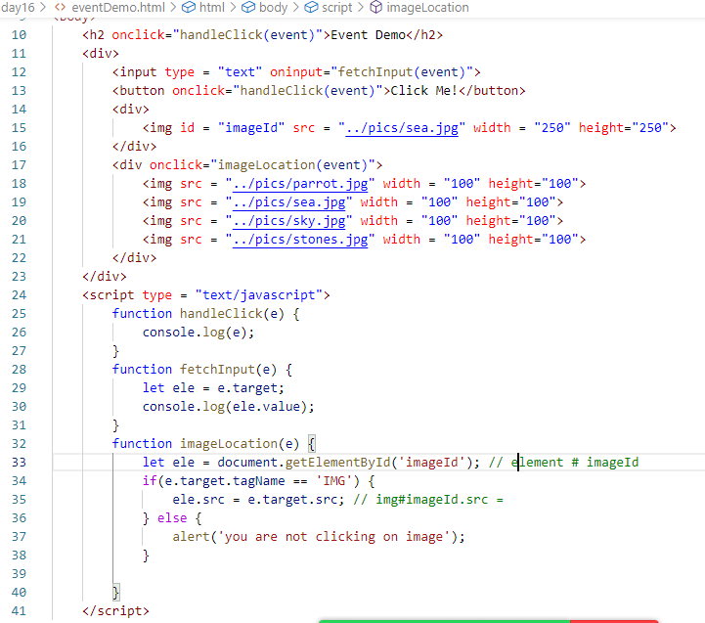

Output:



Inheritance in Javascript

Inheritance is a process of acquiring properties & behaviours of an object from another object.

It is achieved using extends keyword in the class

i.e.,

class B extends A { }

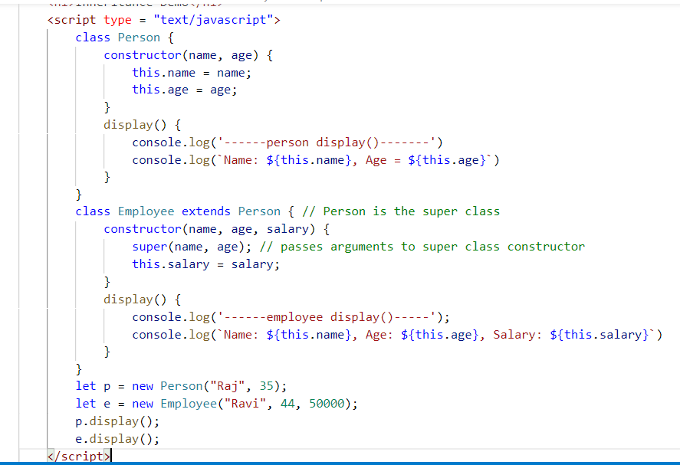

Output:

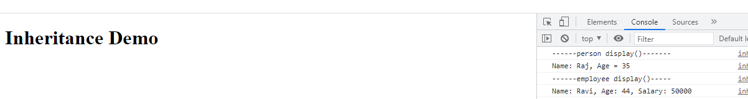

Note: This way of achieving inheritance is a newer one, however developers were using function based constructor to create object & achieve inheritance earlier

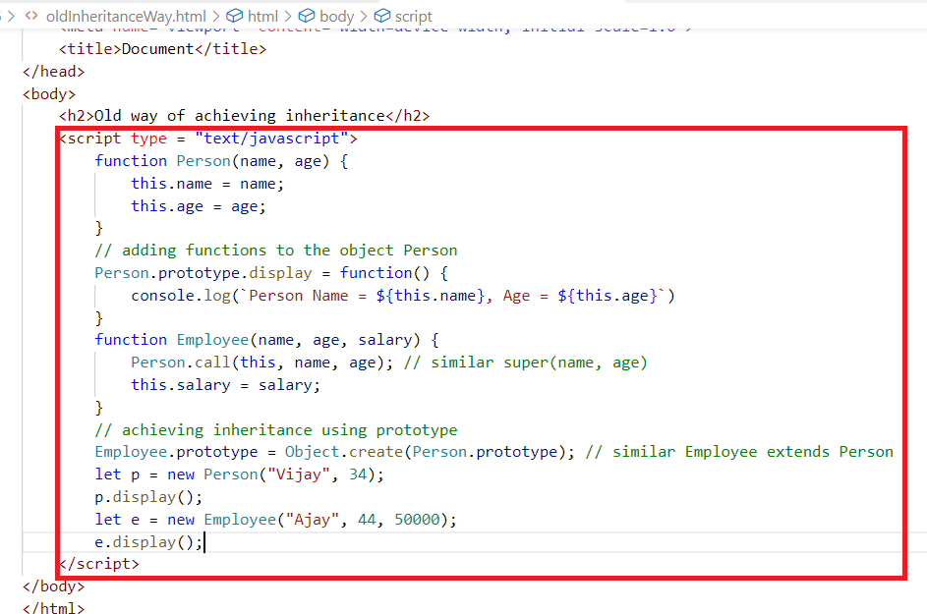

Note: Older approach was a bit complex compare to the newer approach.

Rest & Spread operators

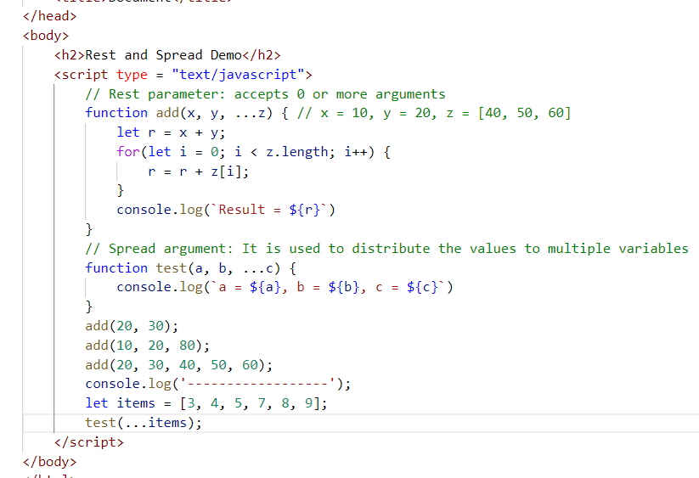

Output:

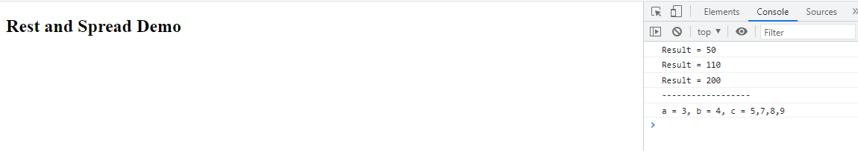

How to perform form validations

When user enters some invalid input you can validate at the client side without sending it to the server, so that server doesn’t need to validate it, this would reduce some extra work at the server side.

You can use javascript to validate such invalid data at the client side so that the request is not submitted to the server

validationDemo.html

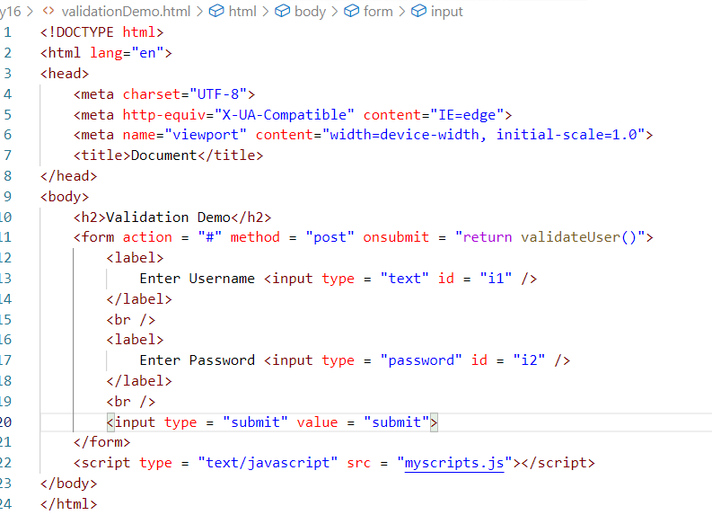

myscript.js

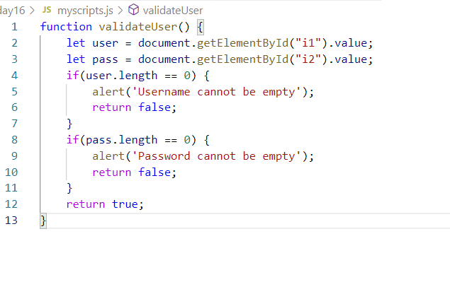

Output:

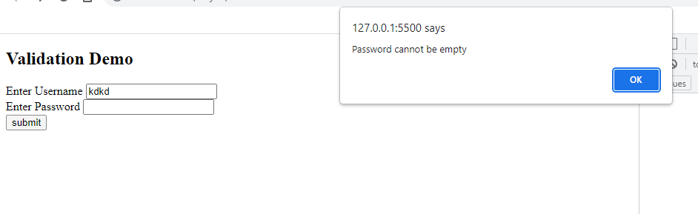

Activity:

Create a form with 3 input box, 1 radio button for gender

1. Fullname
2. Password
3. Confirm Password
4. Gender with Male or Female

Validation:

* Fullname must have more than 3 characters else display alert message
* Password must be more than 4 characters, confirm password should match with password else display alert message
* Gender any one needs to be selected else display alert message

XMLHttpRequest object

This is used by Javascript at the front end to access backend services which could be written in various languages like Java, C#, Javascript, Python and etc.

Backend and Frontend applications use a common format called JSON to exchange their data, this JSON is converted to the datastructure the application can understand.

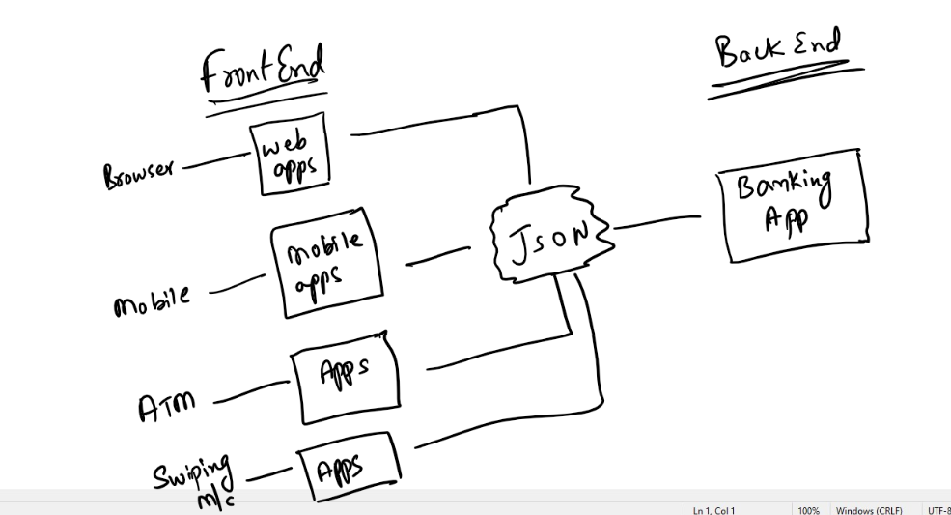

Javascript as a front end can initiate the request and send it to the backend service which sends response ins JSON format then Javascript should convert JSON to Javascript objects.

Note: Not always the request and response share data in JSON sometimes they can just communicate without exchanging the data

Since we have not implemented any backend services currently we can use some fake services in the internet and can get the JSON data from it, this can be consumed by the front end which can implement using HTML & Javascript

We can use below url to access fake service that returns 10 users in JSON format which is an array of JSON

<https://jsonplaceholder.typicode.com/users>

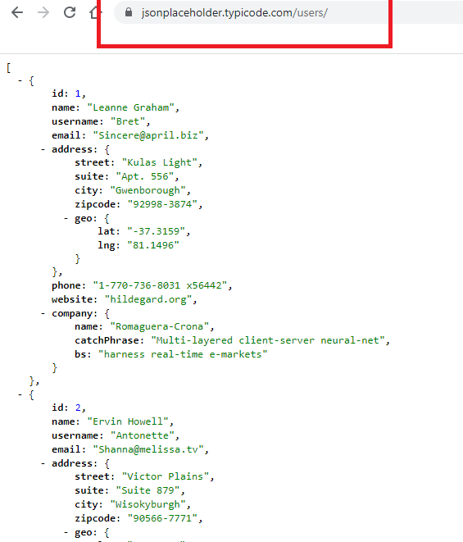

We can also get individual user data using their id’s

<https://jsonplaceholder.typicode.com/users/3>

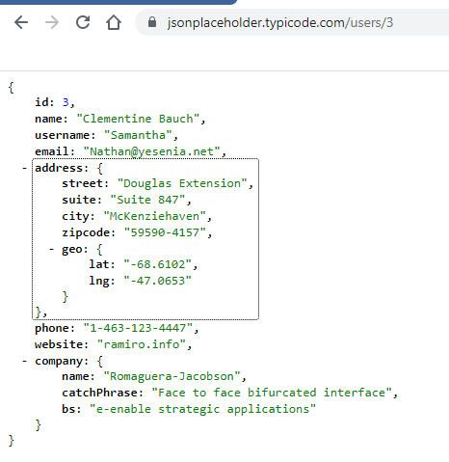

XMLHttpRequest is an inbuilt API available in Javascript to communicate with the Backend services, it can send request with 4 different HTTP methods like post(), put(), delete, get().

Once the request is send XMLHttpRequest provides some inbuilt properties to receive response i.e., responseText is a property used to receive response data from the backend service

callFakeApi.html

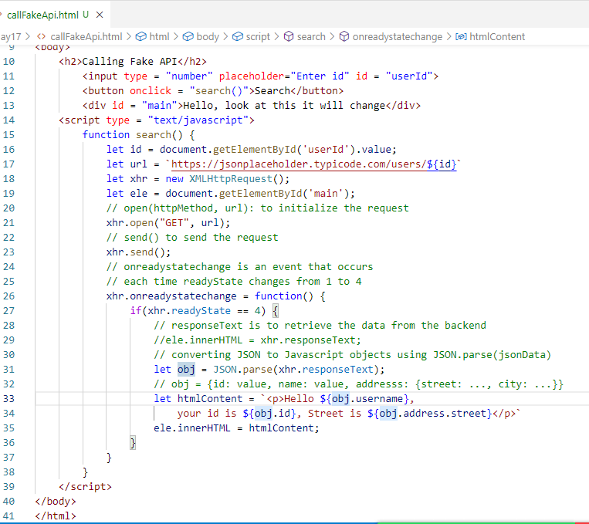

Output:

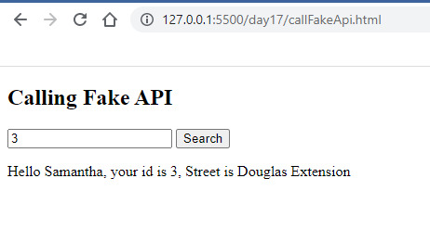

Activity:

Send request to the URL <https://jsonplaceholder.typicode.com/users/>

You get Array of JSON values, convert it using JSON.parse() so that you will get Array of Javascript objects, iterate each object and show it in a table, since each object has many properties you can only show id, name, username, street and city

Duration: 15mins

Solution:

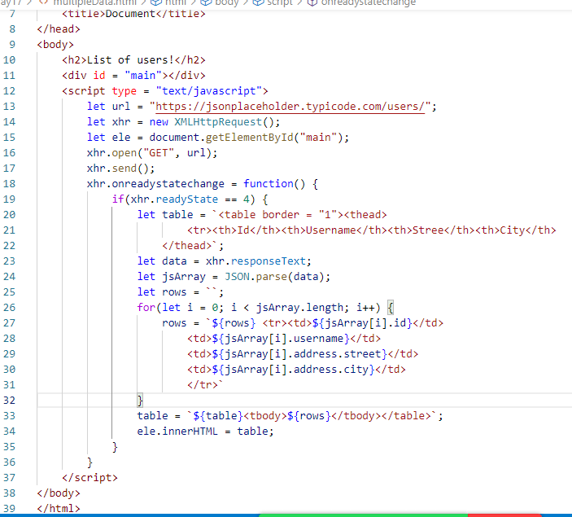

Output:

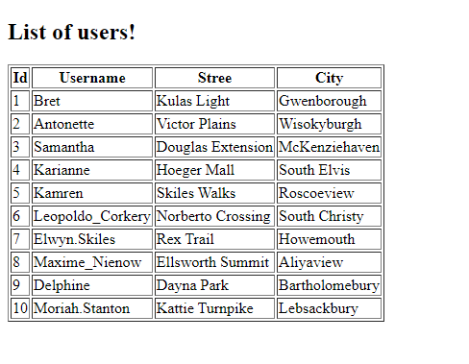

React.js:

It is a Javascript library used to create single page applications, it helps you to create reusable UI (User Interface) components

Single page application: Everything happens in one page, if user does any action it refreshes only part of the page not the entire page, these parts are components that you can independently

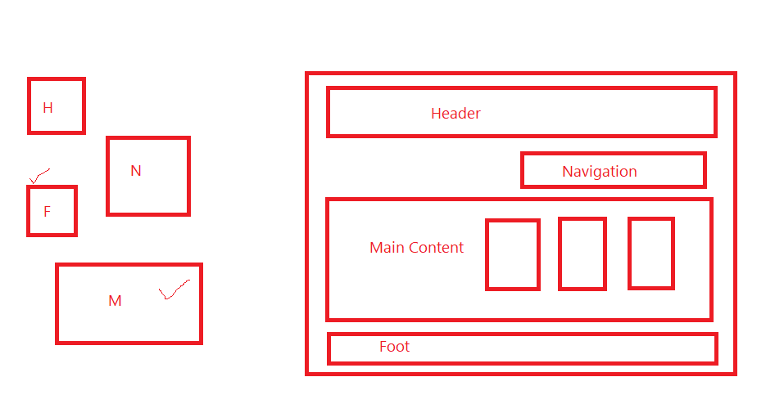

Components: These are UI’s which can be independently created and can be reused in other components

React is all about components

React provides few libraries to develop single page applications

1. React: It is used to create UI components
2. React DOM: It is used to map the UI components to the DOM

React uses 2 technologies to create the application

* HTML
* JSX: Javascript Extension which helps you to easily create HTML elements,

Babel: It is a library which can convert JSX to Javascript, since browser don’t understand JSX we need to use Babel library

There are two ways we can create React Applications

1. Using CDN link for the libraries like React, ReactDOM & Babel and manually creating project
2. Using React toolkit that provides a project template for React applications, it will provide all the necessary libraries like React, ReactDOM, Babel to develop React applications

CDN Link for React

<https://reactjs.org/docs/cdn-links.html>

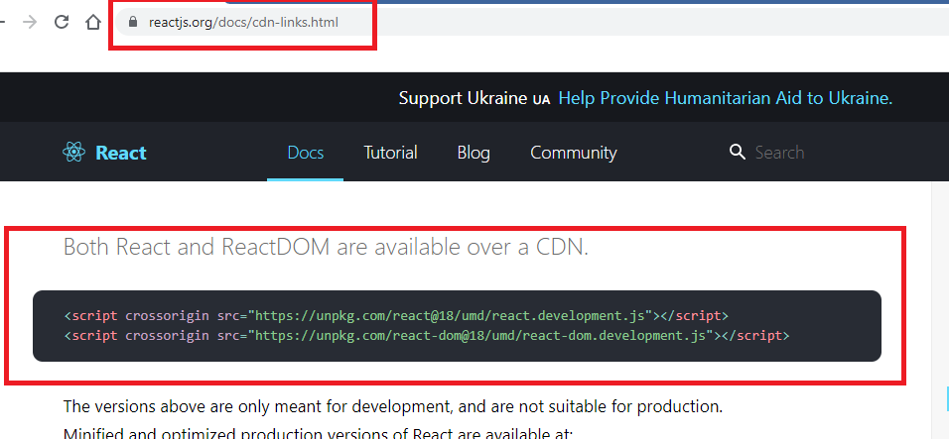

CDN Link for Babel

<https://cdnjs.com/libraries/babel-standalone>

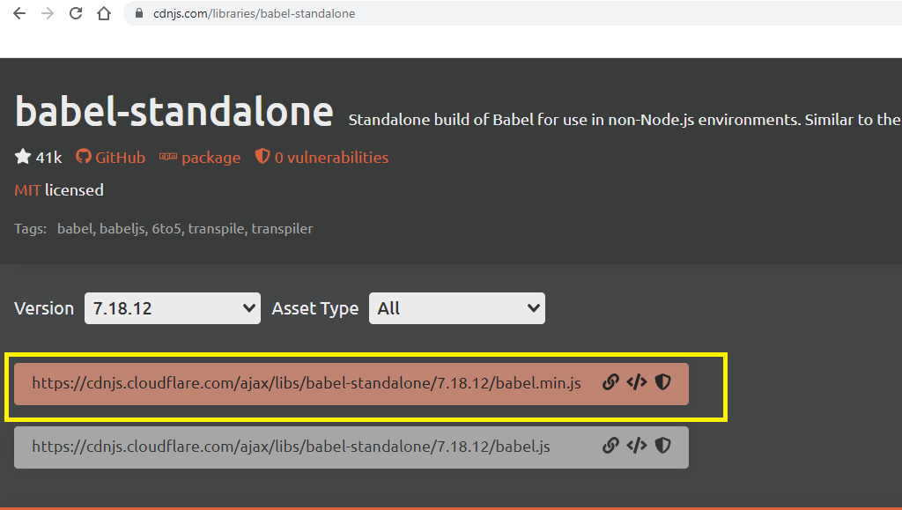

Let us add these links to the html file

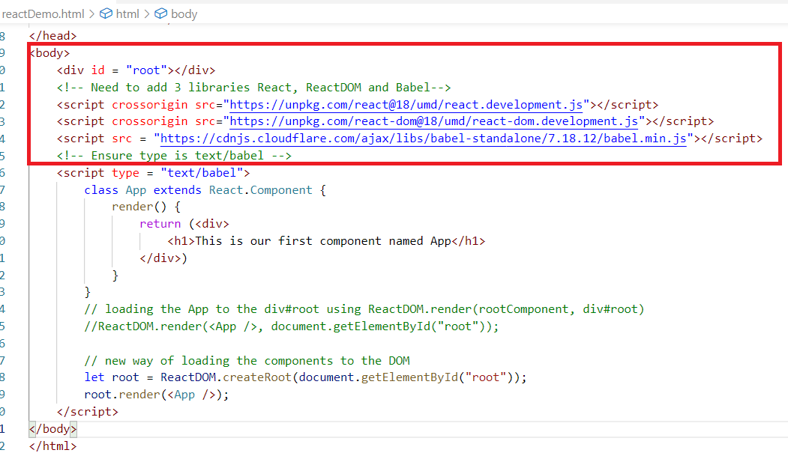

Output:

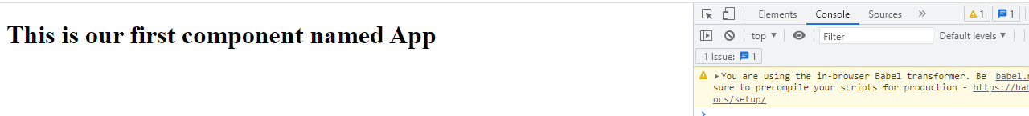

Adding nested components

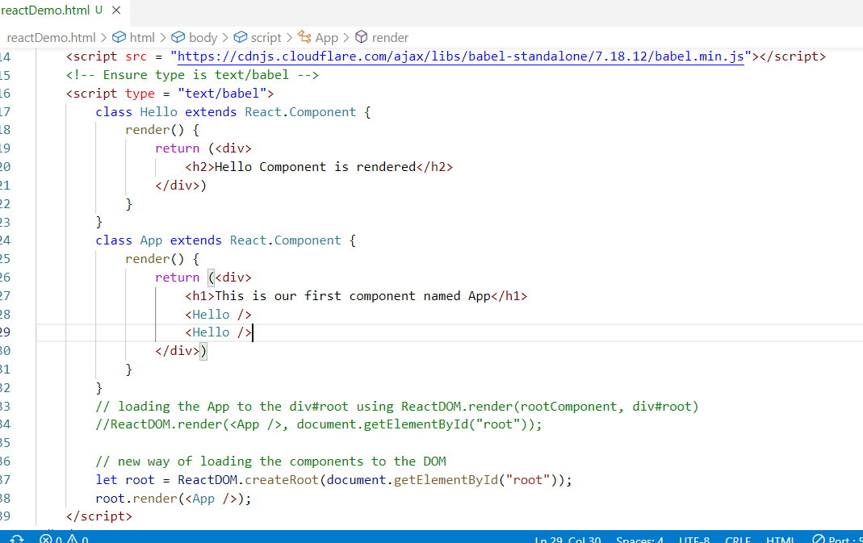

You can nest multiple components so that it appears multiple times in the webpage.

Output:

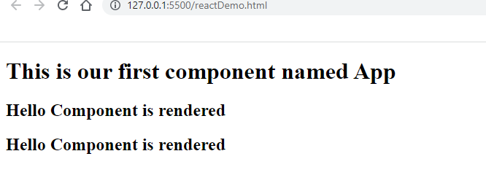

Writing Javascript expressions in JSX

let name = “Raj”;

You can use {name} in the HTML code of your JSX to display the value

let date = new Date();

You can use { date.toLocaleDateString() } in your HTML code of your JSX to display the date value.

Props: It is used to share the data from one component to another component

<Hello name = “Vijay” />  
<Hello name = “Sachin” />

Hello component receives props = {name : Vijay} and another time it receives props = {name: Sachin}

Hello component can use props.name to access the name property

Note: props is an inbuilt property present in React.Component hence you need to initialize it using super(props) in the constructor

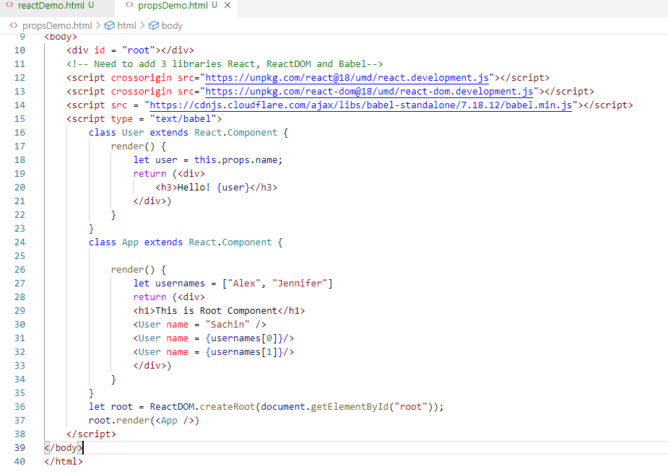

Output:

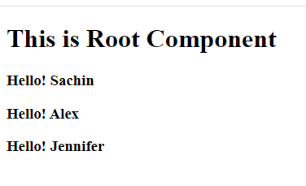

Passing objects with the props

<User profile = {person} />

Here person = {name: “Sachin”, dob: “1990-10-25”}

User can use this.props.profile.name to extract the name & this.props.profile.dob to extract the dob

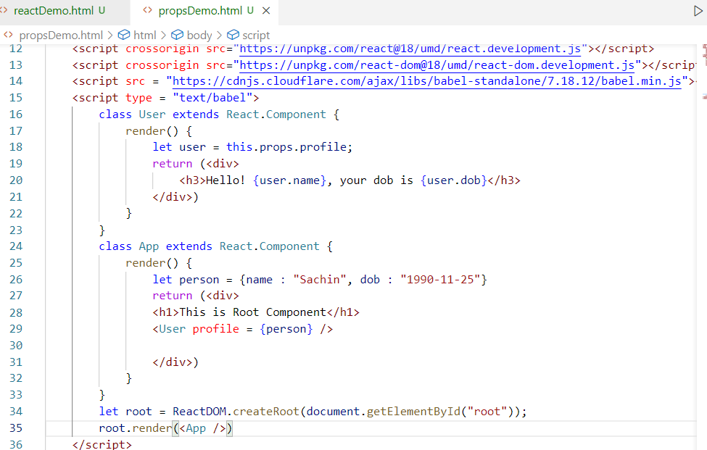

Output:

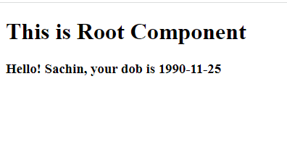

Activity  
Create reusable components to show the comment which will have comment text, commented date, profile who commented with an image

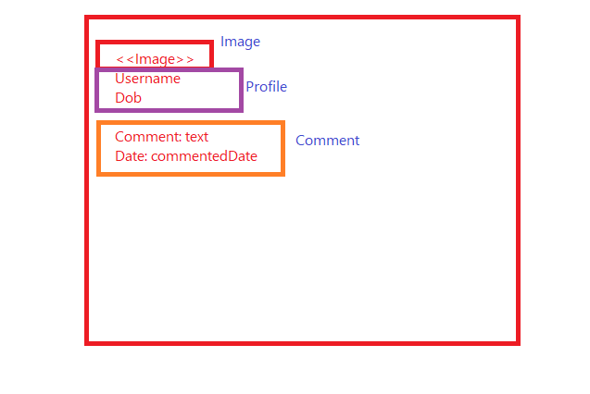

Solution:

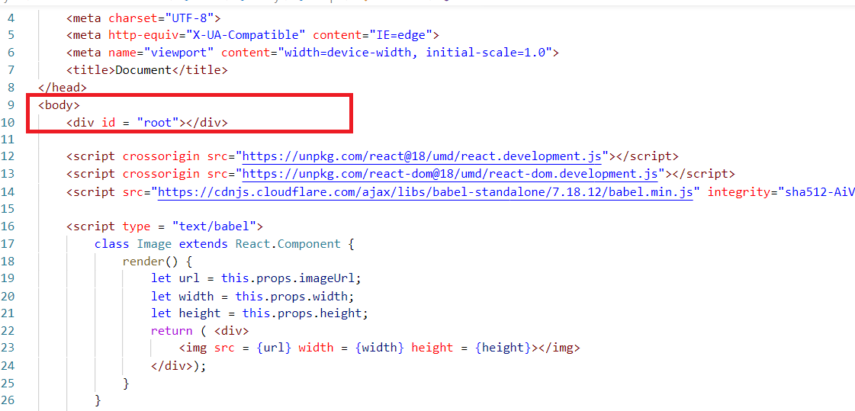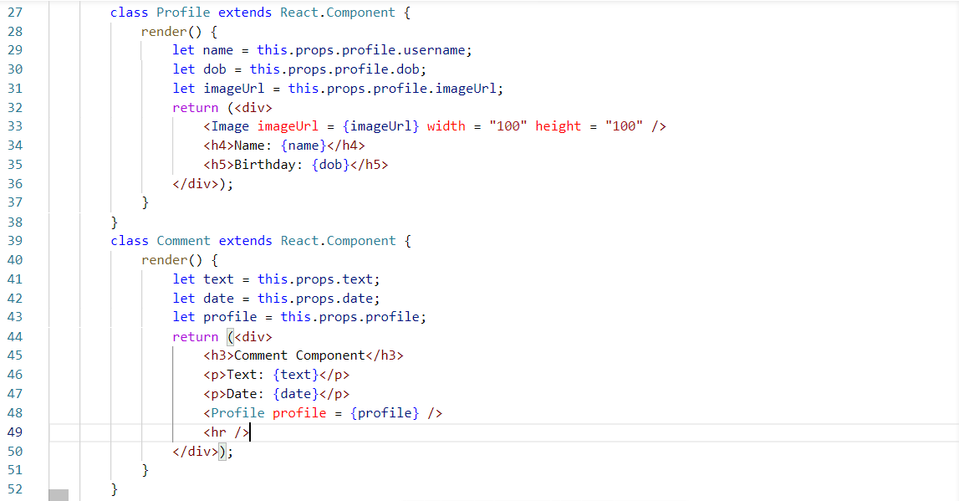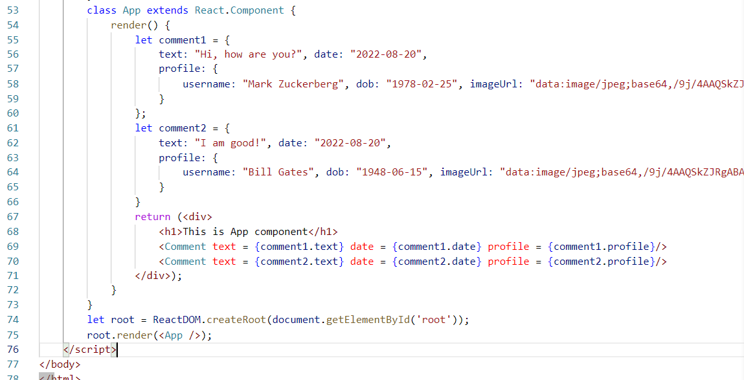

ReactDOM: It is a virtual DOM used by React to map the components to the Real DOM, it increases the performance at the time of updating the DOM by only updating the DOM that need changes and doesn’t refresh the entire DOM tree.

Note: In most of the cases when a particular content of the page is modified, it looks like only part of the page is refreshed, but behind the scene the entire DOM tree will be refreshed, but for us it looks like only part of the page is refreshing

When any technology modifies the part of the content the entire DOM tree will be reloaded, but at the front-end user may not able to recognize that because it looks like only part of the content is refreshing since other contents are exactly same we can’t recognize they are behind the scene re-loaded in the DOM structure

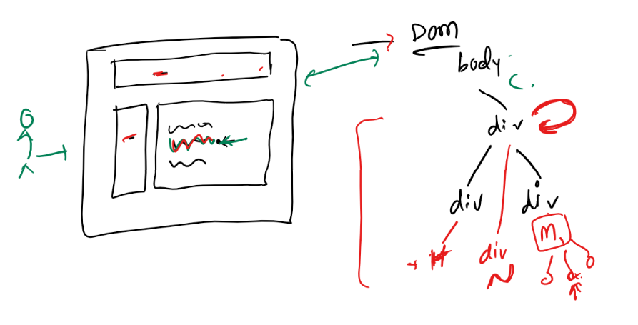

But in React, because Virtual DOM the DOM tree doesn’t refresh as the Virtual DOM compares the Real DOM and only updates the DOM that changed without reloading the entire DOM tree.

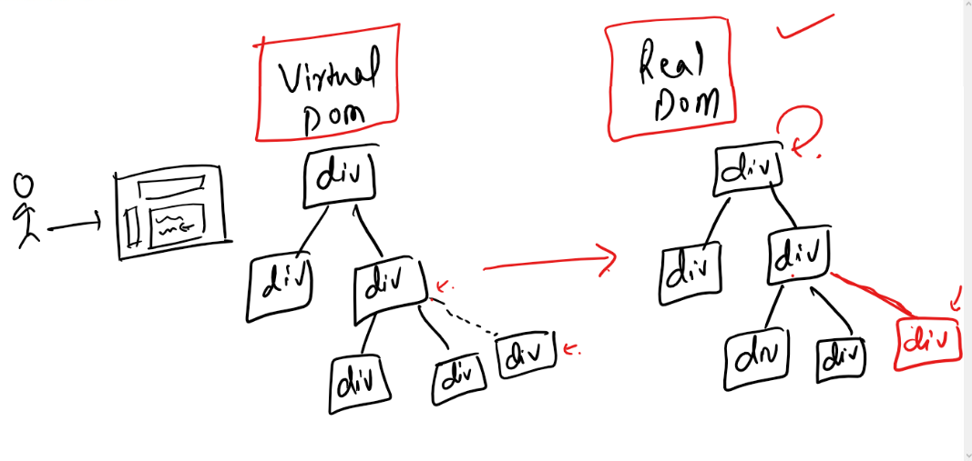

Updating the DOM using Javascript

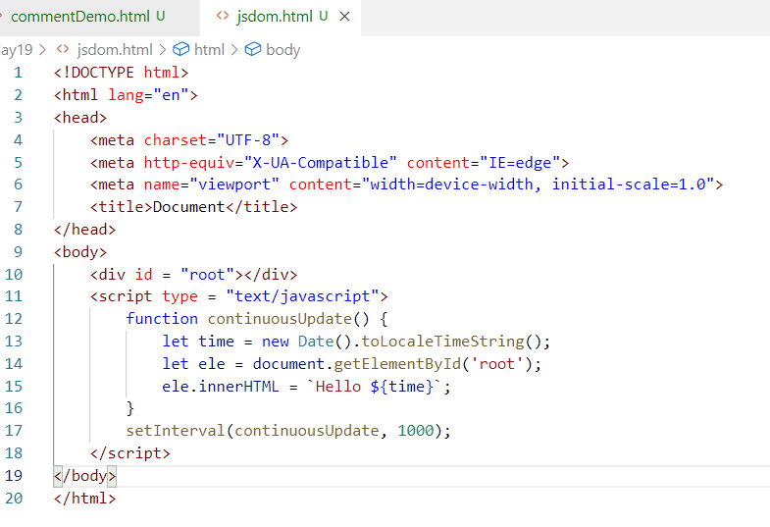

Output:

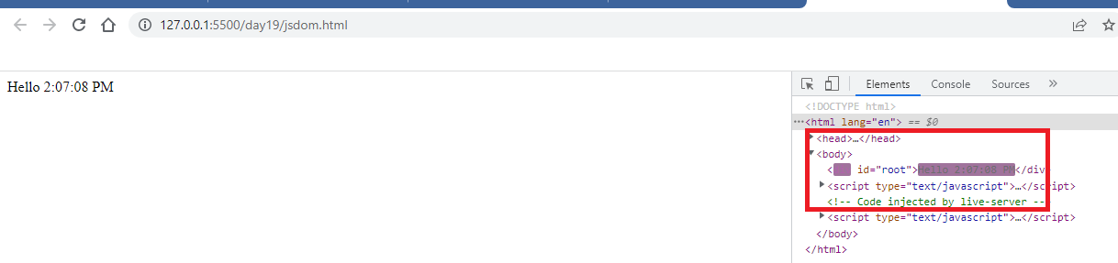

Here the entire <div> is getting reloaded, but since only seconds are changing and other contents are same it doesn’t look like they are refreshing, but we can observe in the DOM tree the entire <div> is getting reloaded.

VirtualDOM avoids this issue by comparing the old content of DOM with the new content the Virtual DOM has to map changes to the DOM, it only updates the DOM content without updating entire DOM tree.

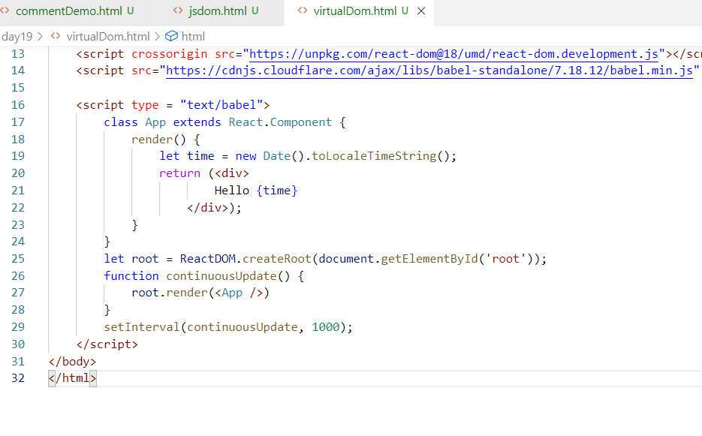

Output:

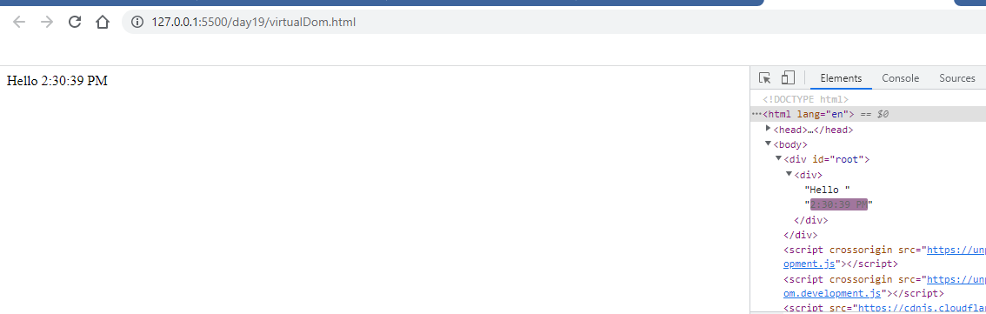

React List and Keys

List is used when you want to iterate over the collection or array of items, each item you iterate can be rendered with an unique key so that React can use the key to access any iterated item.

map(arrow function) is used to iterate the collection of elements

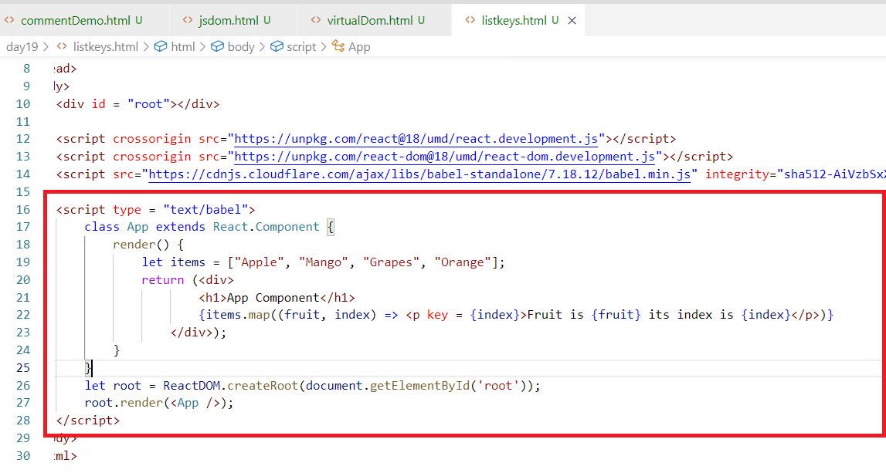

Key: It must be unique, you can access any element in the page via key internally

Functional Components

These are components that can be created using functions, these function names must start with uppercase and can take props as argument if required, function components are used before classes were supported in Javascript even now it is still used because function components are much easier to write.

function App() {  
 return <div> … </div>  
}

The above function is creating an App component, it can be rendered using <App />

You can use props in the function as below:

function Hello(props) {   
 return <div> … </div>  
}

The above function is creating an Hello component, it can be rendered using <Hello props />

React.js came in 2012 when there was no concept of classes in Javascript, during that time React.js used functions to create components, classes in Javascript was introduced in 2015 which led React.js also to use classes to create components, but even now you can still use class/functions to create components

Components created with classes

class App extends React.Component {   
 render() {   
 return <div> _________ </div>  
 }  
}

Components created with function

function App() {  
 return <div> _________ </div>  
}

Both are used using <App />

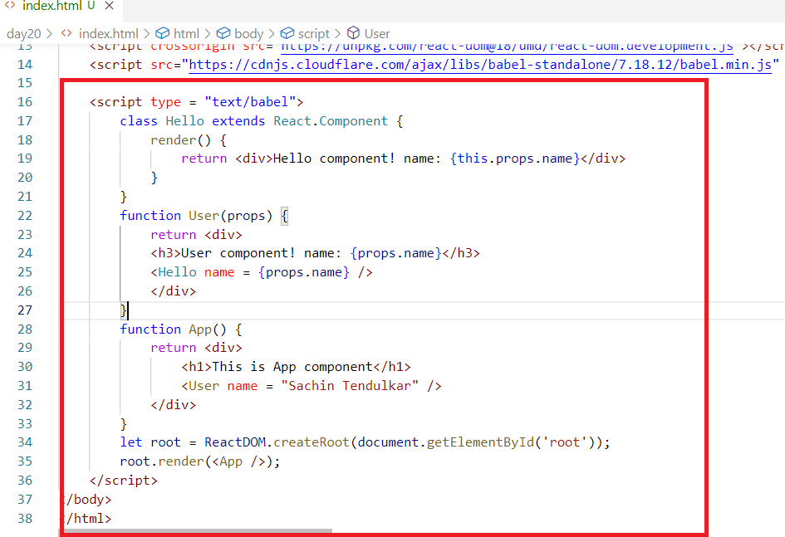

Output:

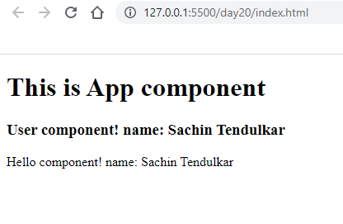

React Toolkit:

It is a software that helps you to create a read to run react application, it gives some commands using which you can launch, build, test, deploy your applications, this toolkit provides a project structure that categorizes html, javascript, configurations in separate folders so that you can easily maintain the application

List of features React Toolkit provides:-

1. Creates Ready to run React application
2. Downloads all the library to run React application like React, React-DOM & Babel
3. Provides an embedded lite server to run react application
4. Provides commands to deploy application in various phases like development, testing, production and so on
5. Provides inbuilt code for root node in a index.html file and inbuilt file that loads the root component to the root node
6. Provides a default template when you launch your application

npx: Stands for **Node Package Execute** It is a command provided by Node.js to execute some libraries online and download some resources in the local machine

There is another command node.js provides apart from npx, which is npm stands for Node Package Manager

npm: It downloads the libraries in your local machine and some of them which aren’t necessary also downloaded

npx: It doesn’t download all the libraries to the local machine except the important libraries

Ex: React tool kit is a library which need not to be downloaded, but can be used online to create React projects

How to install react toolkit

The toolkit name is create-react-app which helps you to create the project by downloading the project online.

>> npx create-react-app <<project-name>>

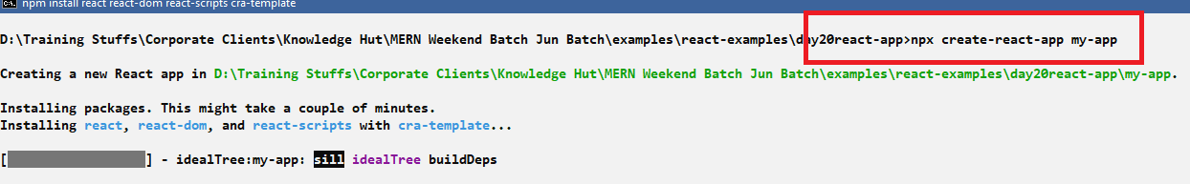

After project is created use cd <<project-name>> & type npm start

npm start: It launches your project & shows the default content of your project that needs to be replaced as per your requirement.

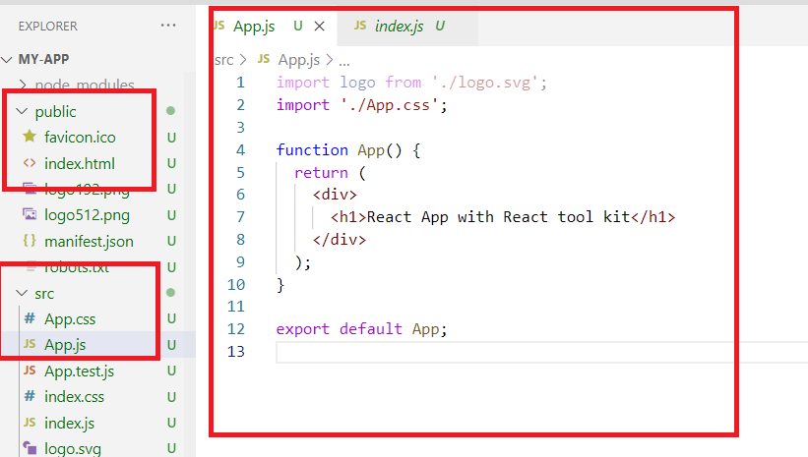

The project is structured to categorize all the javascript code in src, html file in public, all the libraries in node_modules, then package.json will have the configurations related to the project like dependencies, commands, project name, version and etc

Exports & Imports in Javascript

Exports is used when you want to export javascript elements like functions, classes, variables, objects etc to other javascript code

Imports is used when exported javascript elements need to be used in any javascript code

There are two types of Exports

Default & Named Exports

Default Exports: You can have only one default exports in a file which can be imported in any name

Ex: export default some_name;

Ex: import some_name from ‘path’;

Named Exports: You can have any number of named exports in a file which can be imported from the same name

Ex: export some_name;

Ex: import {some_name} from ‘path’;

User.js

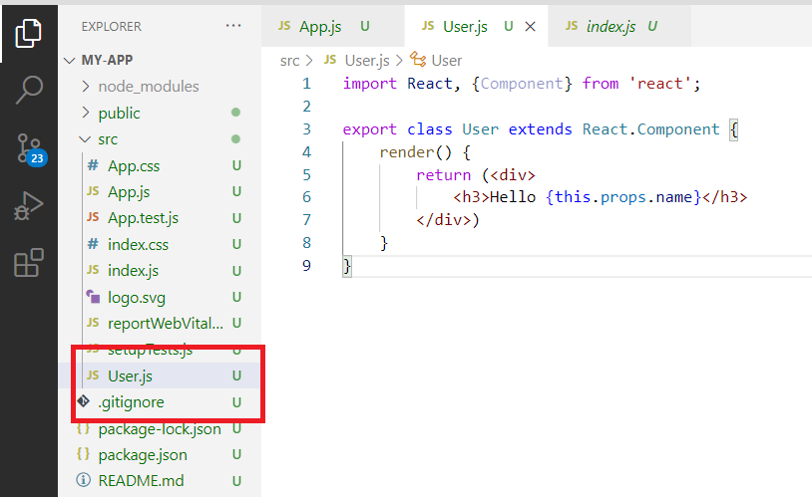

Importing it in the App.js

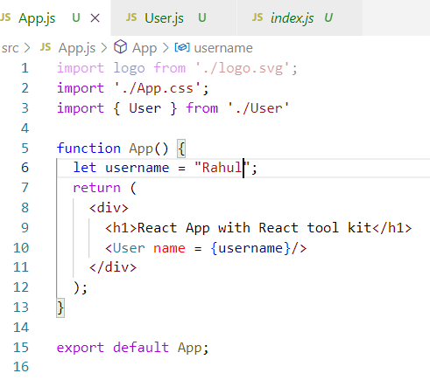

Output:

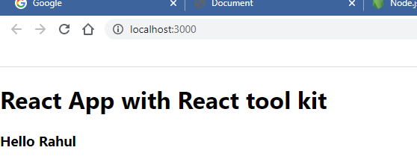

Working with List & Key when we have multiple names

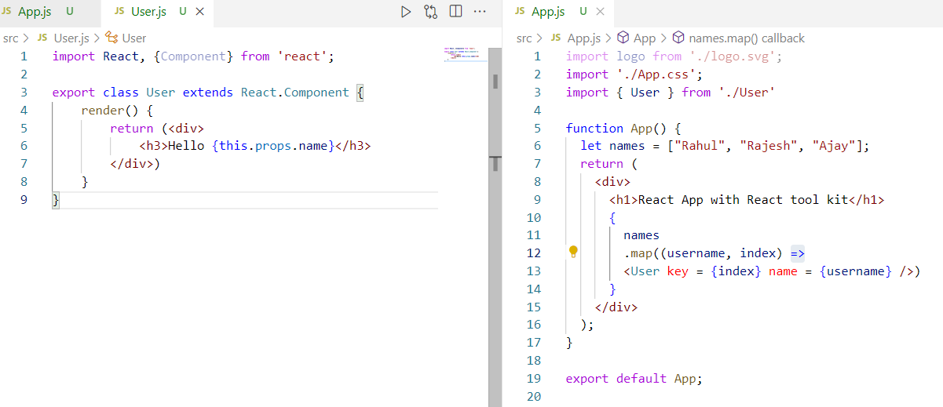

Output:

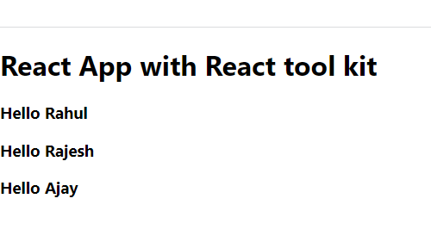

How to add css styles in react

You need to defined the styles in the CSS file and use className in the components instead of class to apply CSS classes

i.e.,

Instead of using

<div class = “abc”></div>

Use

<div className = “abc”></div>

This is because we already have class keyword in the javascript & since we write components content i.e., HTML inside javascript we should avoid using class keyword to apply css class.

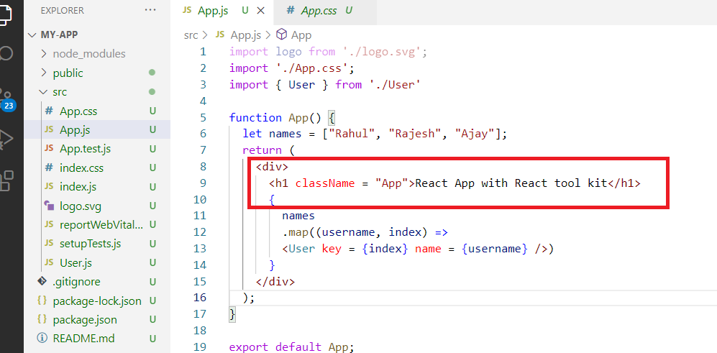

You can also use bootstrap classes by downloading bootstrap library

npm install bootstrap --save >> this command downloads bootstrap library

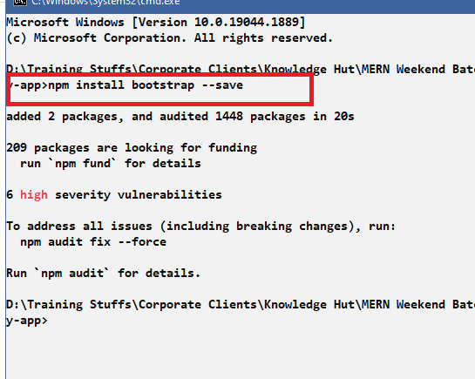

You can see node_modules folder having the bootstrap downloaded

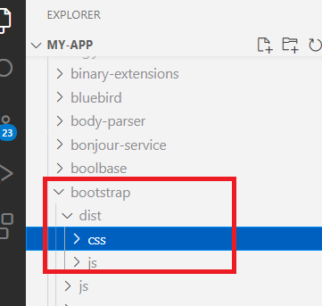

You can import the bootstrap.css file in the index.css and use all the classes of bootstrap

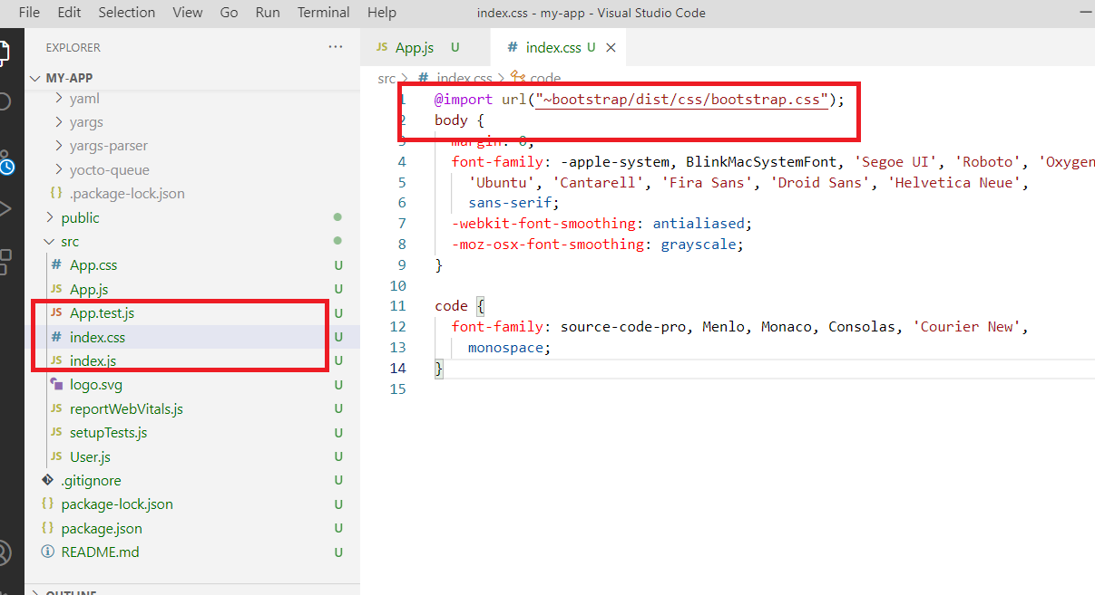

Now you can use bootstrap classes in React

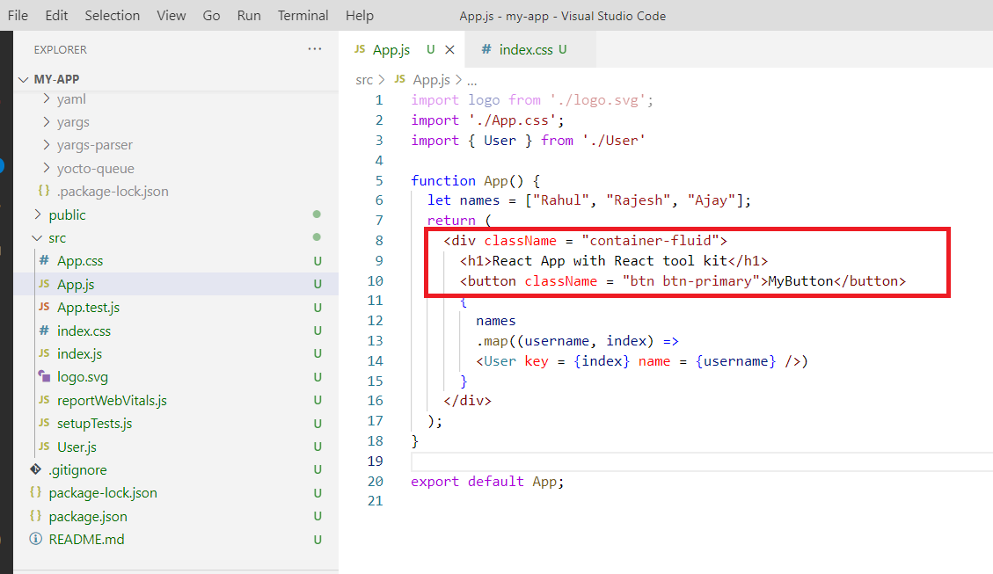

Iterating the complex objects present in the array

components/Demo.js

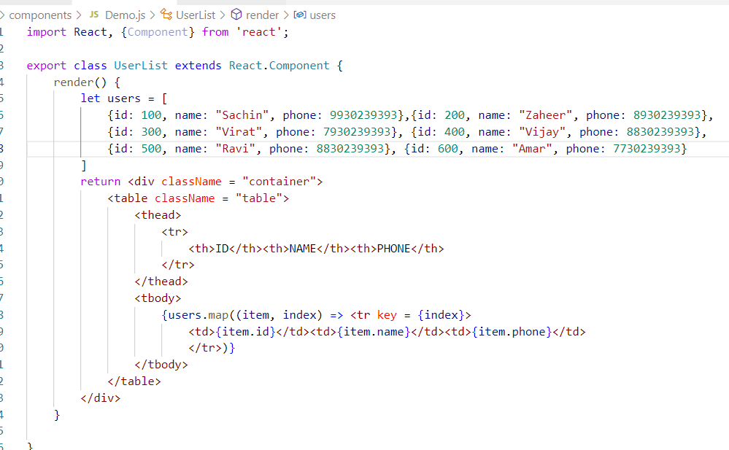

Accessing when some nested properties are absent

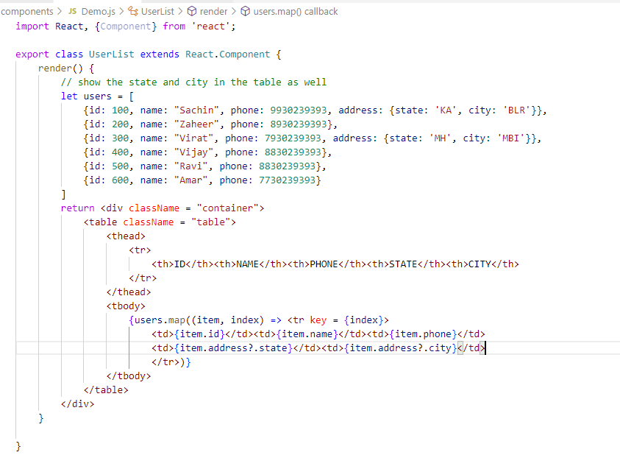

Output:

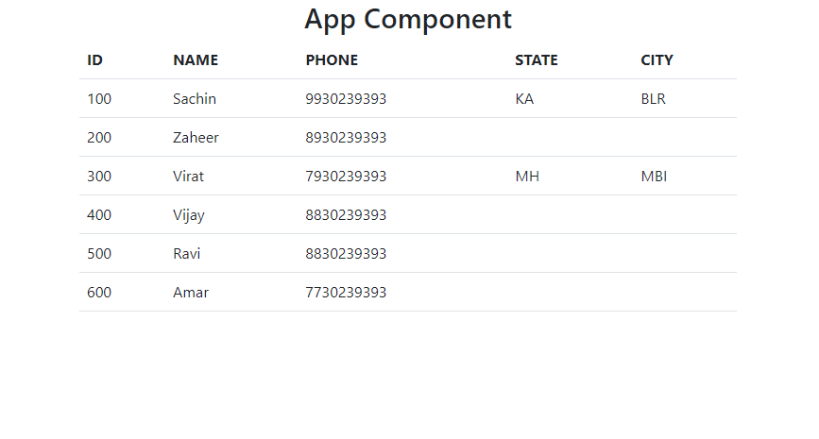

States: These are component properties which can be modified, since components can be created either by using functions or by using classes the way of modifying the states differ depending on the how the components are created

State vs Props

1. State is used to store the data in the component it is both readable & writable
2. Props is also the represents the data of components and its read-only

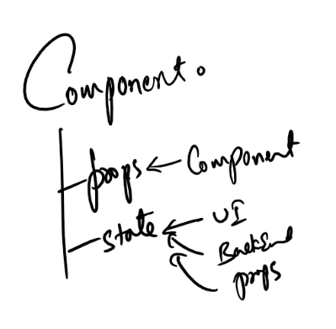

Every component will have props & state, the props are data coming from the other components like parent components, however the states are the data which can be updated from the User Interface or From the Backend or from the Props

State in Component class

When you extends React.Component you will get a property inherited called this.state which must be initialized in the constructor, however to modify that you will have another method that is also inherited called setState({}), this you can use in any place when you want to update the state

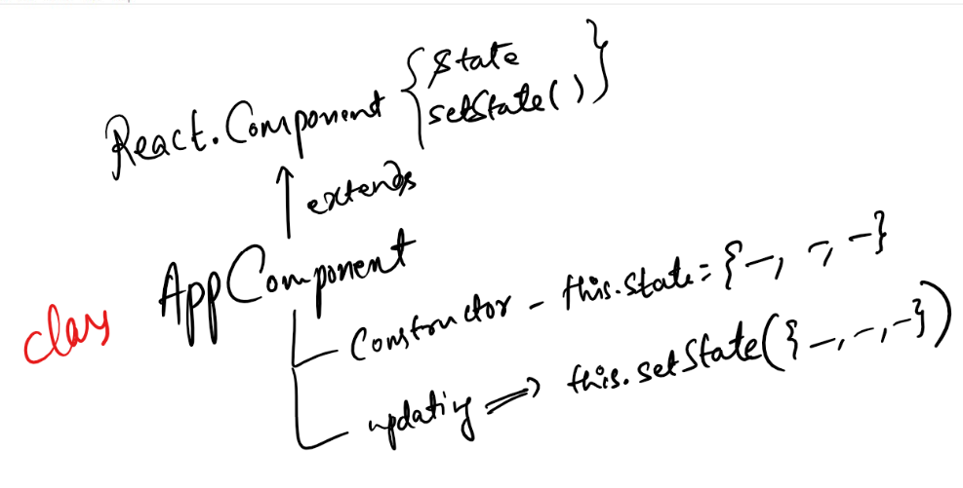

constructor() {   
 this.state = { id: ‘ ‘, name : ‘ ‘, phone : ‘ ‘}  
}

someMethod() {  
 this.setState( { id : 100, name : “Raj”, phone : 9939939 } )  
}

Event Handling

Events are objects that are generated when user does some interaction with the components could be click, mouse over, mouse out, key press, input, on change and so on.

These events needs to be handled so that we can extract the event and see what changes the user wants to make.

Binding the events to the handlers

handleClick = () => {   
 ….   
}

<button onClick = {handleClick}>MyButton</button>

Note: In React.js all the event names must begin with lower case followed by camel case for the subsequent words, below are the list of the events

onClick

onSubmit

onChange

onMouseOver

onMouseOut

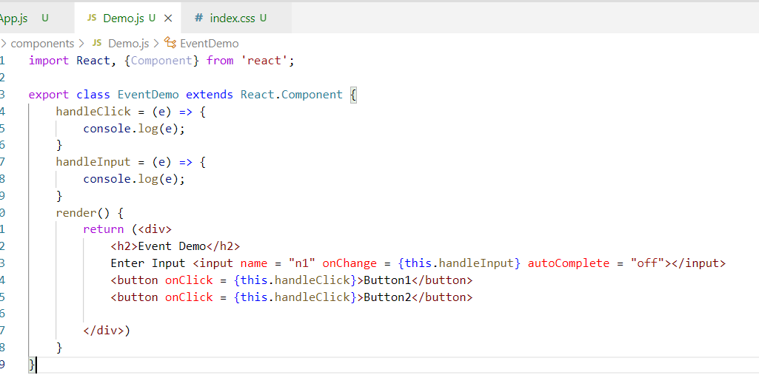

Output:

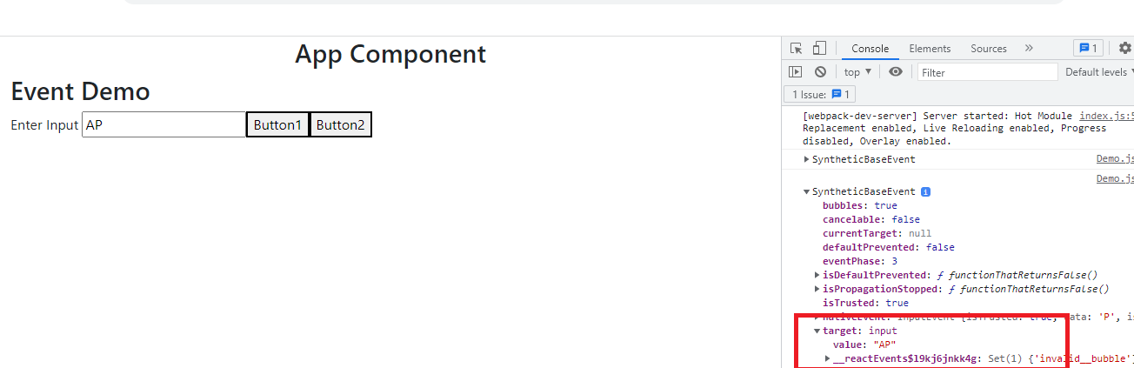

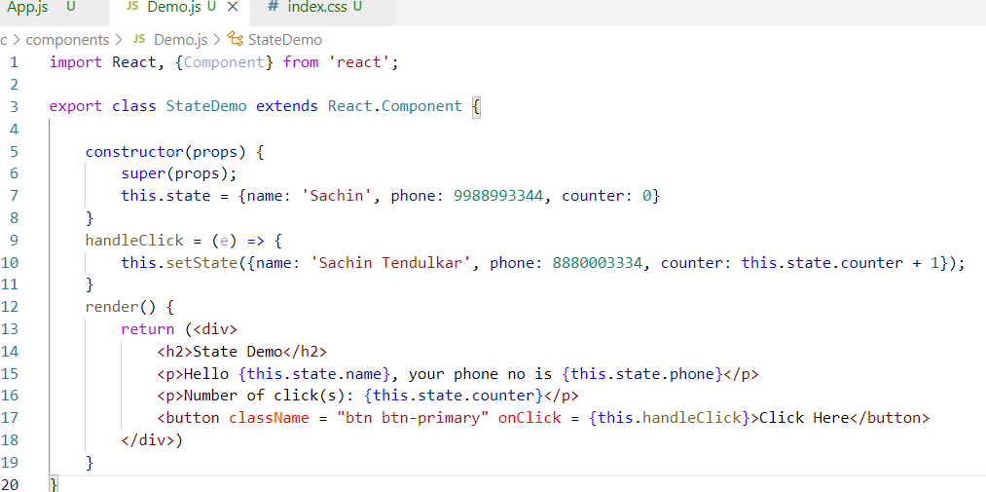

Output:

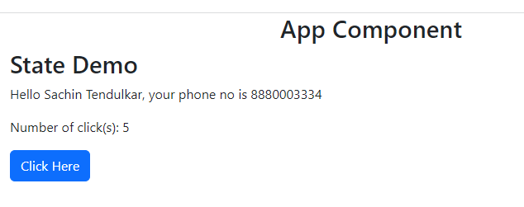

Conditional Rendering using states

You want different components to be shown on different conditions.

if(condition) {  
 return <ComponentName />  
} else if(condition) {  
 return <ComponentName />  
}

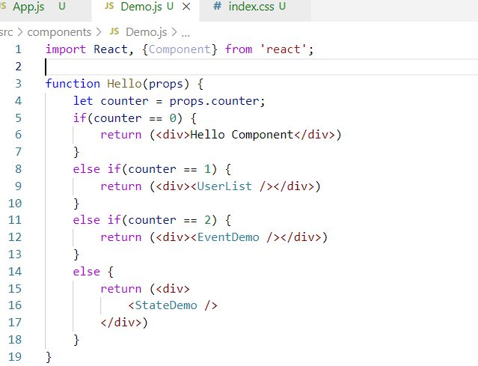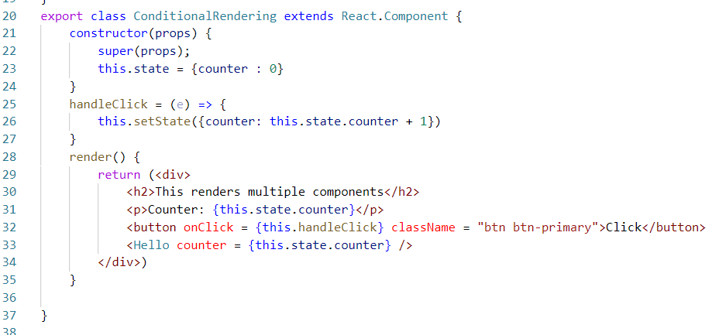

Here every time the counter value changes you could see different components loading

Day 22

>> npx create-react-app second-app

>> cd second-app

>> npm start

>> In another terminal >> npm i bootstrap --save

Open index.css import the bootstrap.css from node_modules

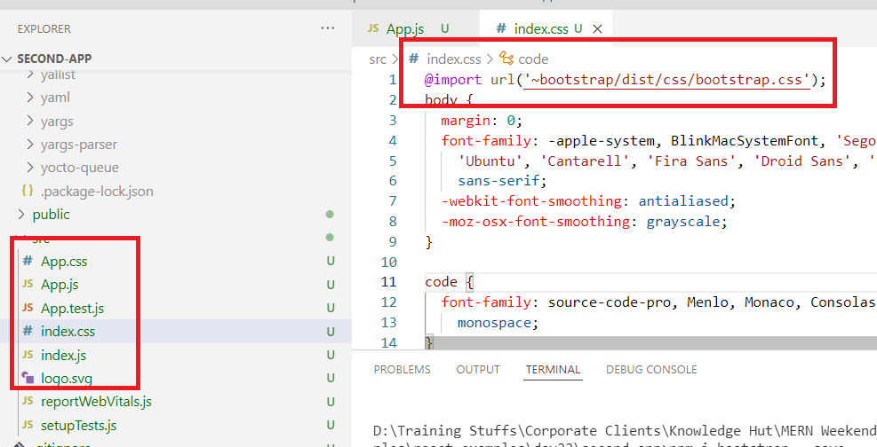

How to create states in components via functions

We have an inbuilt react hook function called useState() this will help you to create the states & functions to modify the state in your components

import { useState } from ‘react’;

To create the state we need to use this useState() that takes default value of the state and defines the state & method that modifies it

function User() {  
 [name, setName] = useState(‘’);  
}

To create event handler for the components we need to create a variable that is bound to the event handler

let handleClick = ( event ) => {   
   
}

App.js

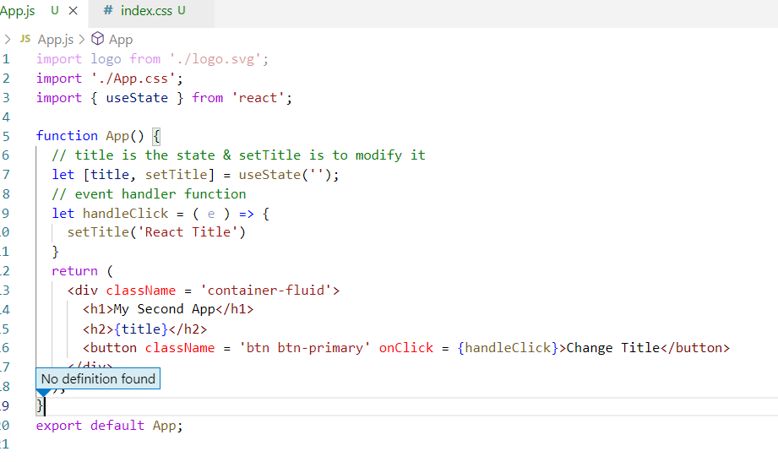

Output:

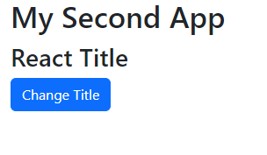

Controlled Components / Forms Handling in React

The components that will have form controls are called as controlled components, the name is because the components state handle the data

Forms help to accept user input and submit to the backend, you can use the event handler to update the form data to the state and submit it to the backend

src/Forms.js

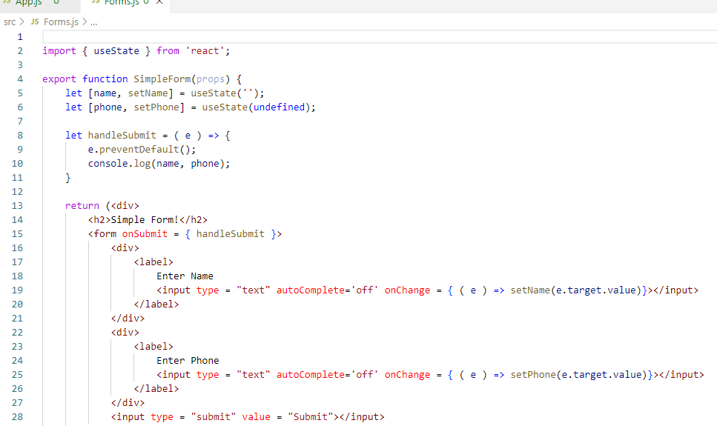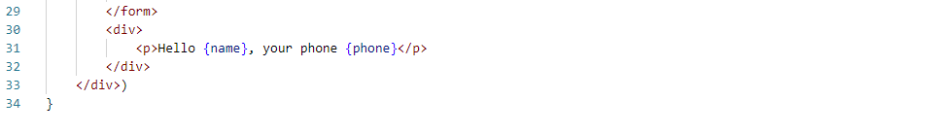

App.js

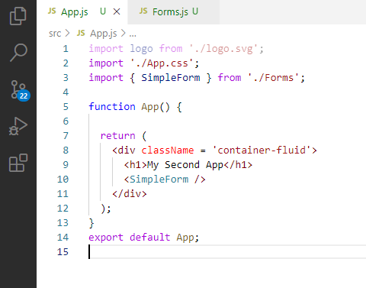

Output:

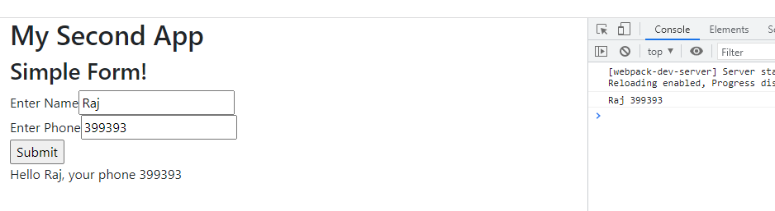

React.Fragments

Suppose you want some html elements to be rendered without having a container tag like <div> then you can use <React.Fragments>

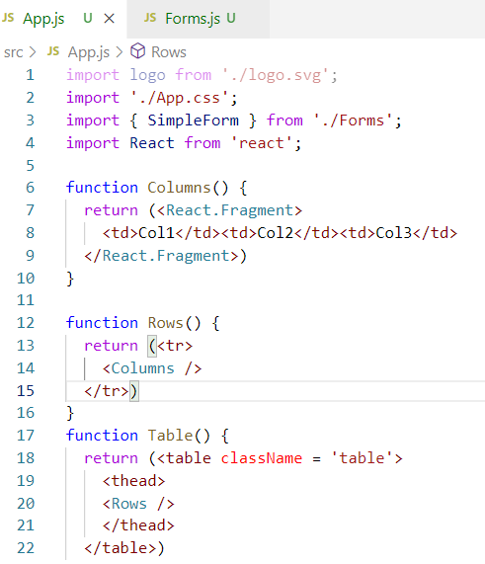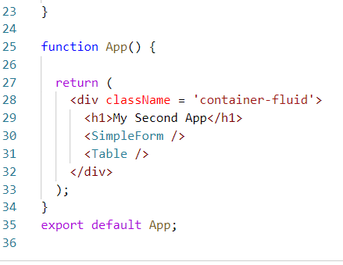

Output:

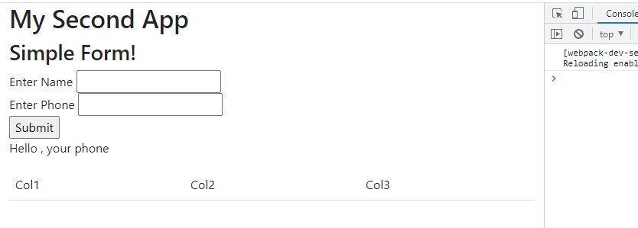

Calling Backend API’s using axios

Backend API’s are online services with HTTP methods & URL’s using it we can make any applications to use the data shared by these services.

Backend API’s share the data to the applications in JSON format, which needs to be converted to the structure the Front end application can understand

axios: It is a 3rd party javascript library which can make HTTP request to the Online API’s, these API’s are called as REST API’s which stands Representational State Transfer which generate the data in JSON format and also accepts the data in JSON format

This JSON format must be converted to the structure your application understands

ex: JSON must be converted to React understandable format if React uses axios library to access online API’s similarly React must send JSON data to these online API’s which inturn converts JSON to the structure they can understand

axios library installation

npm install axios --save

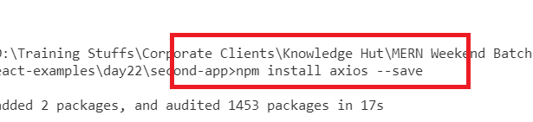

Online API’s will have URL’s and HTTP methods for the clients to access the data or share their data in JSON format

The HTTP methods specifies the type of operations which is an understanding between clients & the online API’s

HTTP GET: Fetch Operation

HTTP POST: Store Operation

HTTP DELETE: Update operation

HTTP PUT: Modify operation

Frontend applications acting as a client should use above HTTP methods when they want to perform any CRUD operations like Store, Retrieve, Update & Delete, similarly

Backend applications uses the same HTTP methods when they want to perform CRUD operations and it provides URL to access these HTTP methods that does CRUD operations.

axios library provides http methods that accepts URL to call the backend api’s, and some methods also takes data when they want to send data to the backend api’s, these data must be in JSON format.

axios methods return Promise when they want to send request, these promises could be either fulfilled or rejected which can be identified through the callbacks passing to .then() & .catch()

.then(callback): It is used when promises are successful, then the callback is used to get the success response

.catch(callback): it is used when promises are failed, then the callback is used to get the failure response

Ex:

axios.get(url).then(callback).catch(callback)

axios.post(url, jsonData).then(callback).catch(callback)

axios.put(url, jsonData?).then(callback).catch(callback)

axios.delete(url, jsonData?).then(callback).catch(callback)

Currently we can use only get() from the axios to call fake rest api as we don’t have any other api’s that can be called with other HTTP methods

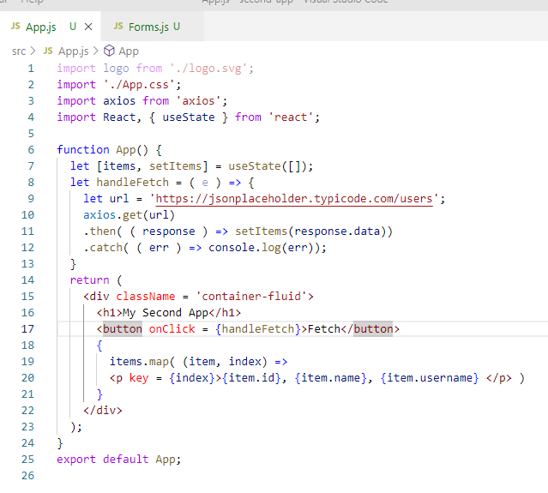

Output:

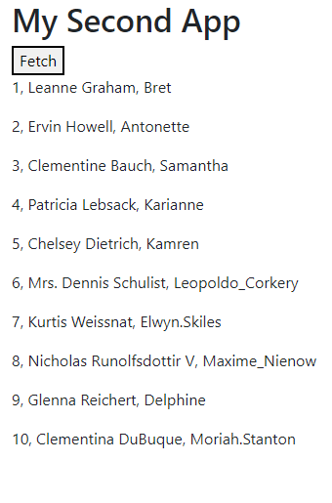

Topics to look for

* Create Ref
* useEffect hook

React Routers:

It is used to navigate from one component to another component based on the link the user clicks or sends, it helps to dynamically load the components in one page without refreshing the entire page.

By default Routers are not provided by react, hence we must download react-router-dom library. ‘npm install react-router-dom’

React Router Dom  
It gives us some predefined components that helps to add routing features to our application

1. BrowserRouter
2. Link
3. Route
4. Routes

BrowserRouter: It must be a parent component for all the components including the root component, this is the one that helps to add the component dynamically.

<BrowserRouter>

<App />

</BrowserRouter>

Link: It gives the path to the components <Link to = “/login”>Login</Link>

Route: It gives the path & component configuration, that helps BrowserRouter to load the component when a particular path is matched, Route will replace the component in place of it

<Route path = “/login” element = {<Login />} />  
<Route path = “/save” element = {<Register /> } />

Routes: It is a collection of <Route> that selects any one <Route> based on the path which helps <BrowserRouter> to load the component

<Routes>  
 <Route path = “/login” element = {<Login />} />  
 <Route path = “/save” element = {<Register />} />  
 <Route path = “/about” element = {<About />} />  
 …

</Routes>

Installing React Router DOM library

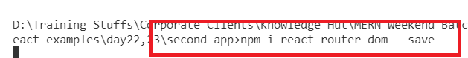

index.js

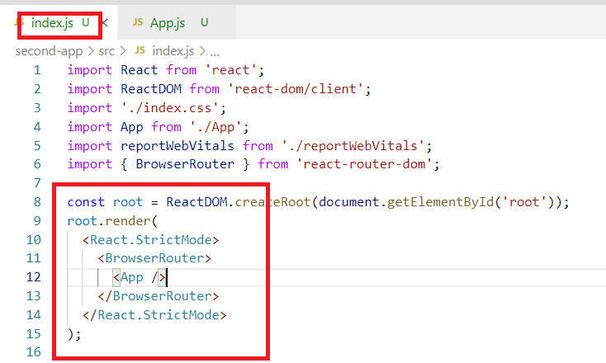

App.js

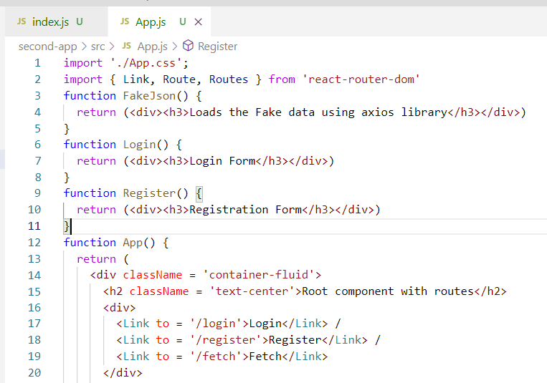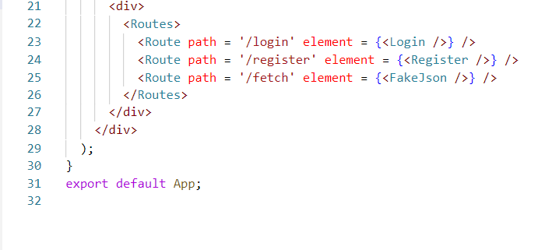

Performing the CRUD operations in React application using Fake API’s with the help of JSON Server

JSON server helps to create Fake API’s that maintains the data in a json file, using it you can build your Front-end applications without having backend, JSON server would be useful when backend api’s are not ready yet for front end developers.

npm install -g json-server : This installs json-server globally

json-server -v: It is used to verify the json-server installation

json-server -w is used to run the json file which needs to be used for CRUD operations with post, put, delete & get

Create one fakejson file to help json-server to watch

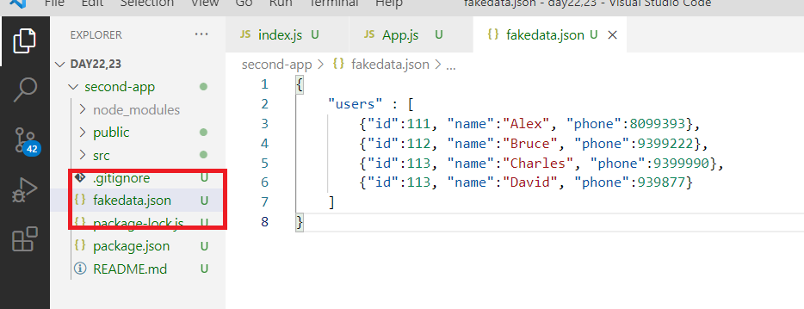

By default json-server can recognize the duplicates using the key “id”, now you can use “/users” to get all the data stored in the array

“users/111” is used to operate on the data having he id 111, this is the inbuilt program of json-server to understand id property is used to access a particular data

You can use browser address bar to test the json-server GET method

Firstly you need to launch the json file using -w or --watch, and if you want to change port number use -p or --port

i.e., json-server -w filename.json -p 3001

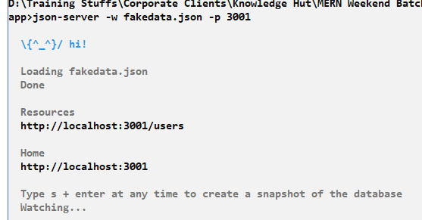

Now we can use the url to perform CRUD operations using http methods from axios library, through post() you can store the user data but we must have id property

axios.post(url, jsonData).then( callback ).catch( callback )

axios.put(url, jsonData).then( callback ).catch( callback )

axios.delete(url, jsonData).then( callback ).catch( callback )

axios.get(url).then( callback ).catch( callback )

App.js

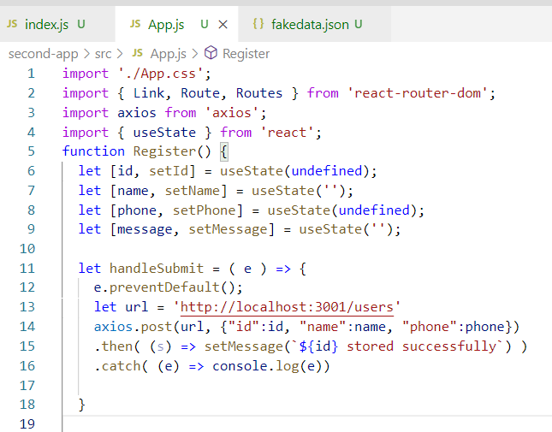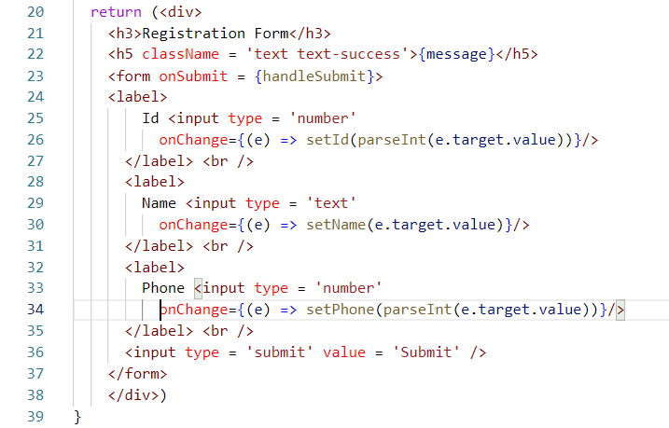

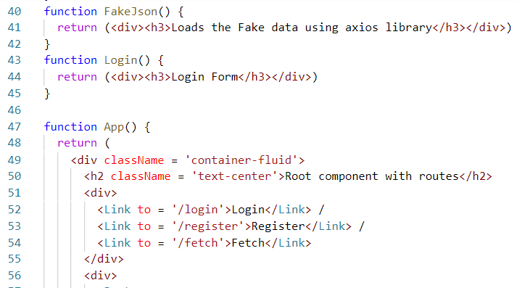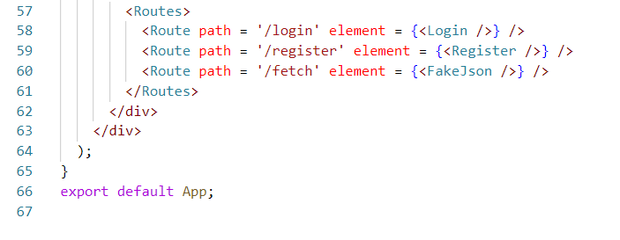

Output:

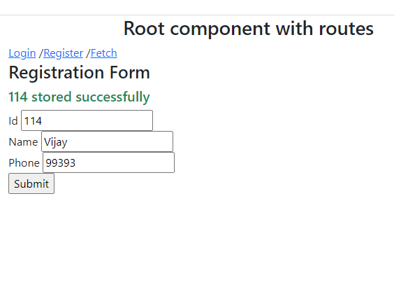

Performing delete operation

You can use the id of the object and delete the data using axios.delete(url)

App.js

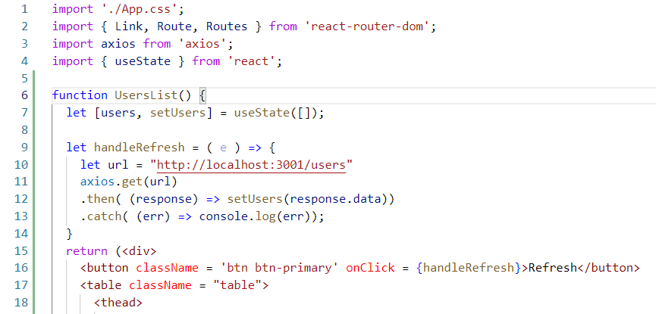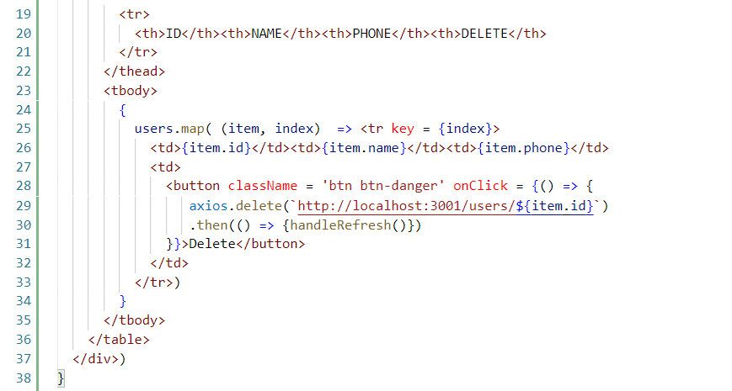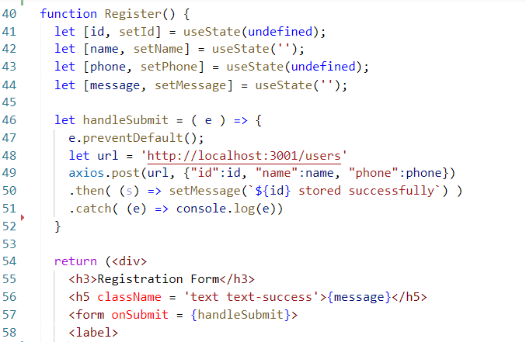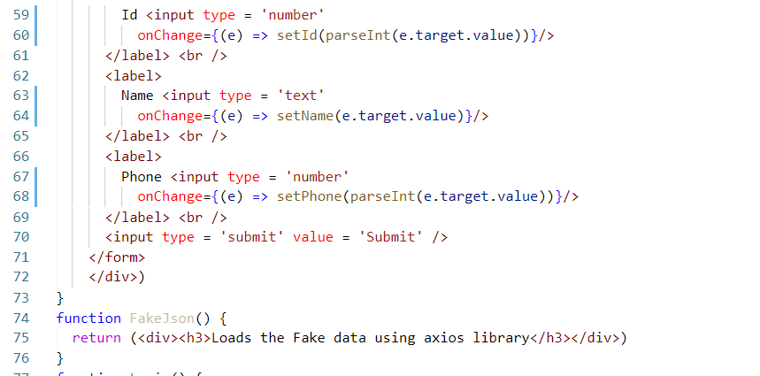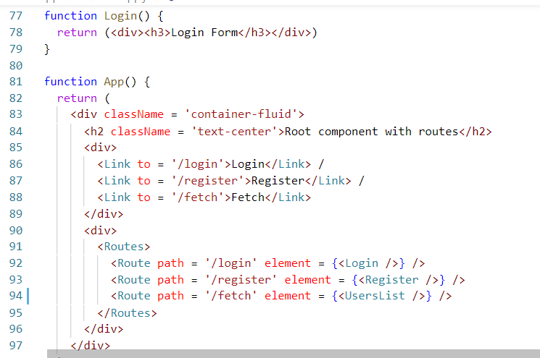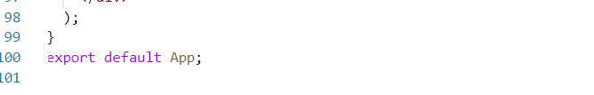

The program will have links to store & list all the users, the users list component shows all the users when you can click on a button then on each row you could see a delete button that sends request to the json-server using axios.delete(url/:id), here :id is a dynamic id based on the iteration the button will have an id.

Node.js

It is a runtime environment to run the javascript at the backend without browser, node.js provides many inbuilt libraries in the form node_modules which helps javascript to be executed on the backend to create server side programs,

Benefits of using node.js

* It helps to write Javascript to create server side programs
* Developers who already have idea on Javascript for Front-end can use the same technology to write server side programs without learning any new technology
* JSON is the common data-format used to exchange the data between front-end & back-end applications, JSON is the native language for Javascript so it is easy for Javascript to use JSON without any translation
* Node.js provides many inbuilt libraries + external libraries from npm repository that helps javascript to interact with any backend resource could be a file, process, database and etc.
* Node.js also follow ECMA script standard so it can understand latest features of Javascript

Note: Node.js doesn’t understand some inbuilt objects of browsers like sessionStorage, localStorage, window, document, alert() and so on

package.json: It is the heart of node.js application, it can be used to keep all your application informations like commands, dependencies, application version, name and so on

It is recommended to keep package.json in your node application

>> npm init -fy: This is the command that creates package.json file in your folder

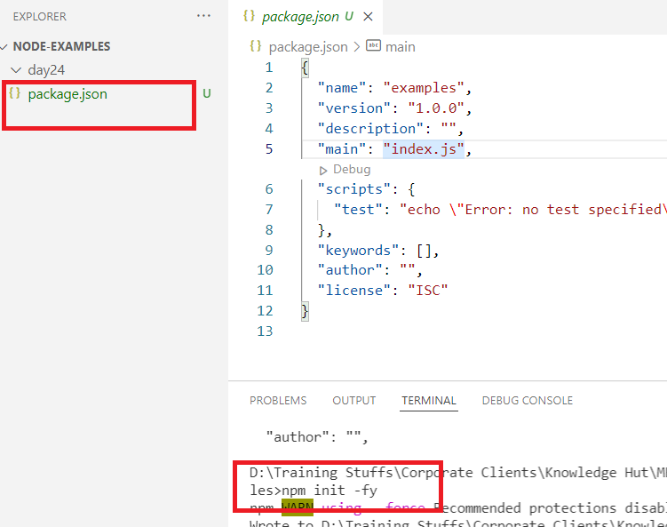

To run your javascript you can use node command followed by the file name

>> node filename.js

first.js

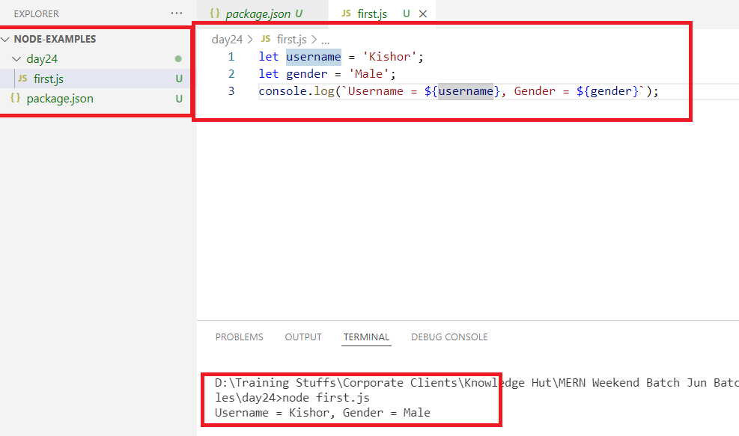

second.js

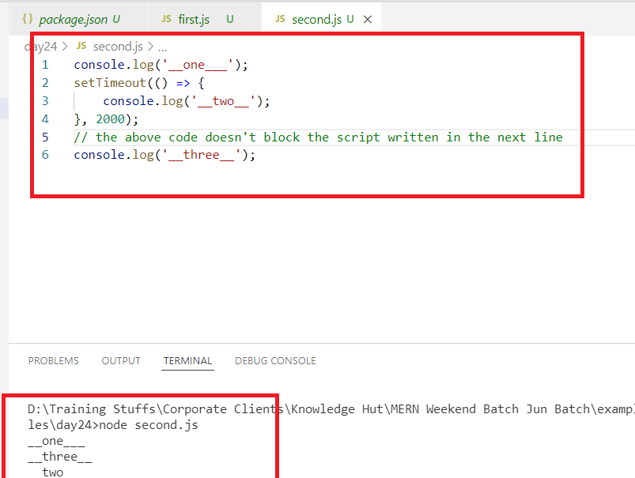

You can notice the script is not blocking the 5th line because callback is executed later and the operation is asynchronous

Event loop mechanism

Node.js is single-threaded, which concentrates only on event loop and doesn’t perform any operation on the major tasks rather it concentrates on only handling the requests, because of that it doesn’t block the script as the majors tasks are done by asynchronous functions

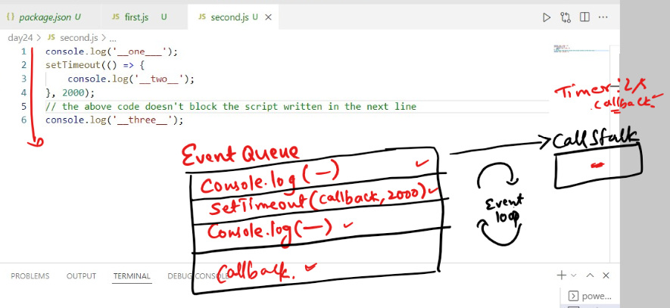

Modules

These are reusable libraries or Javascript elements like class, function, variable, object, which you can import in another Javascript file to reuse them, it is of 3 types

1. Local module: Which we can create to use in various part of the code
2. Core module: Which comes inbuilt with node even this can be reused in various part of the code
3. Third party module: Which needs to be downloaded from the internet and import in our code

Local modules

These are javascript libraries that must have exports to import in other parts of the application.

Default Import: When you only one module to import then you can use this

utility.js

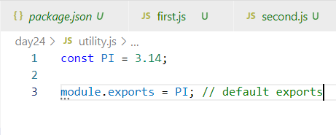

third.js

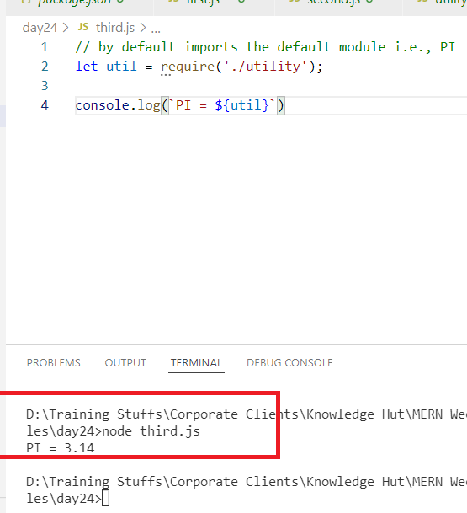

Named Imports & Exports

When you have multiple modules then you can use name to import & export

utility.js

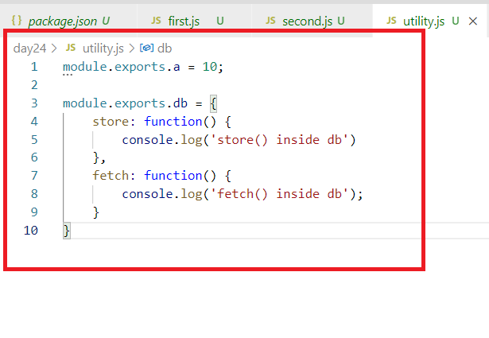

fourth.js

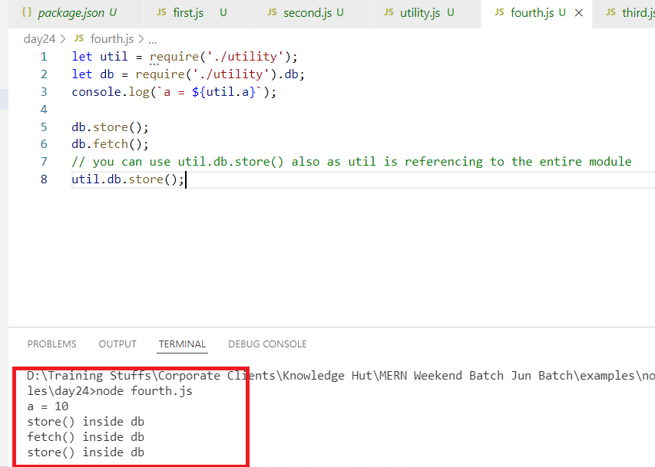

Activity:

1. Create a local module that will have a calculator object with 4 functions add, sub, div, mul, all the functions take 2 arguments & return the result
2. add(x, y): should return addition of x & y, similarly sub(x, y): should return subtraction of x & y, similarly mul & div must return the values
3. Import this calculator in another javascript & call these 4 methods and print their result in the imported script file

i.e.,

let cal = require(‘./calculator’);

let r = cal.add(20, 30);

console.log(`r = ${r}`);

Named exports can also be written in a way where you can export multiple modules at the same time

module.exports = {a, b, c}

Here a, b & c are some modules

let a = function() { …. }

let b = function() {….}

let c = function() { …}

module.exports = {a, b, c}

Core Modules

These are the modules provided by node.js which you can import and use in your javascript code, below are some core modules which are widely used.

1. os
2. fs
3. http
4. url

os module: It is a module that has default exports so that you can import directly without any name

let os = require(‘os’)

It used to access informations related to OS like architecture, platform, release and so on.

let os = require(‘os’)

os.arch(); // to know the architecture of the os

os.platform(); // to know the patform like windows, mac

os.release(); // your os release numbers

os.hostname(); // you can get the host of the os

five.js

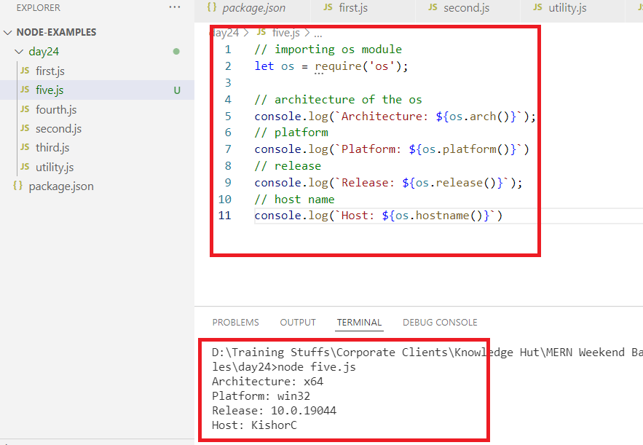

Third party modules

These are the modules which needs to be downloaded from the internet and use in the script, some of them are

* express
* readline-sync
* body-parser
* mongodb
* cors

readline-sync:

It is used to take user input from the console, it has a function called question(), questionInt(), questionFloat() that waits for user to enter input.

Installing

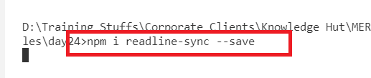

Importing

let read = require(‘readline-sync’);

read.question(…..) // waits for user input

read.questionInt(…)// waits for user to enter number

six.js

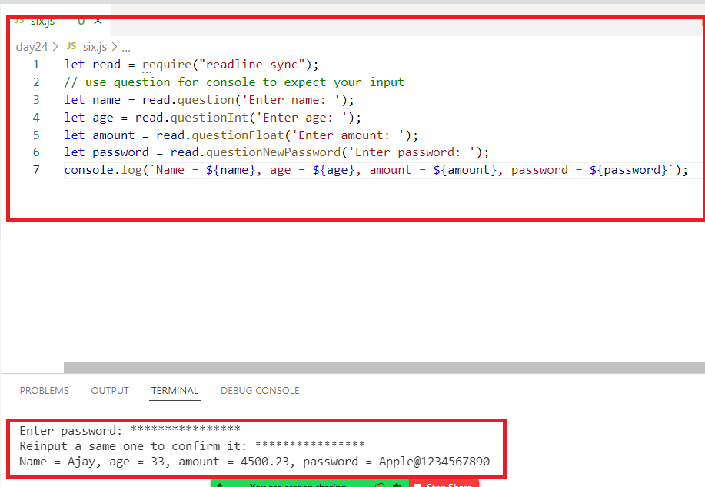

We can use javascript programming constructs like loops, conditions, arrays, classes &objects

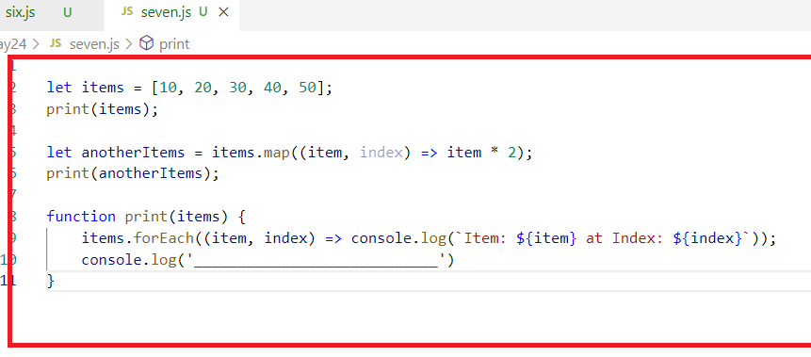

Activity:

Create a class with the name Employee in a file employee.js, initialize employee properties like id, name and salary using constructor arguments, in Employee class create a display() function that prints the id, name and salary, make this class as a module and import in another javascript file called main.js.

main.js needs to have a continuous loop that accepts input from the user like 1, 2 and 3, when user enters

1: it must ask user to enter id, name & salary that initializes employee object and store the employee object in the array, accept id, name & salary at runtime using ‘readline-sync’

2: it must iterate on the array that has stored employee object and on each iteration it must call the display method of Employee on each iteration

3: If you enter 3 then the loop must stop

Repeat the loop to either store or display until you enter option ‘3’;

FS Module

When an application written in node.js wants to read/write files then you can use fs module, it can be imported using require(‘fs’), it provides two methods called

1. readFileSync(filename);
2. writeFileSync(filename, content, {flag:’a+’})

Reading the file from some location

D:\test.txt

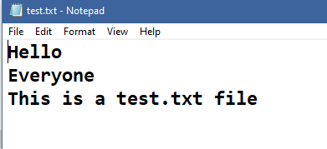

day25/filereading.js

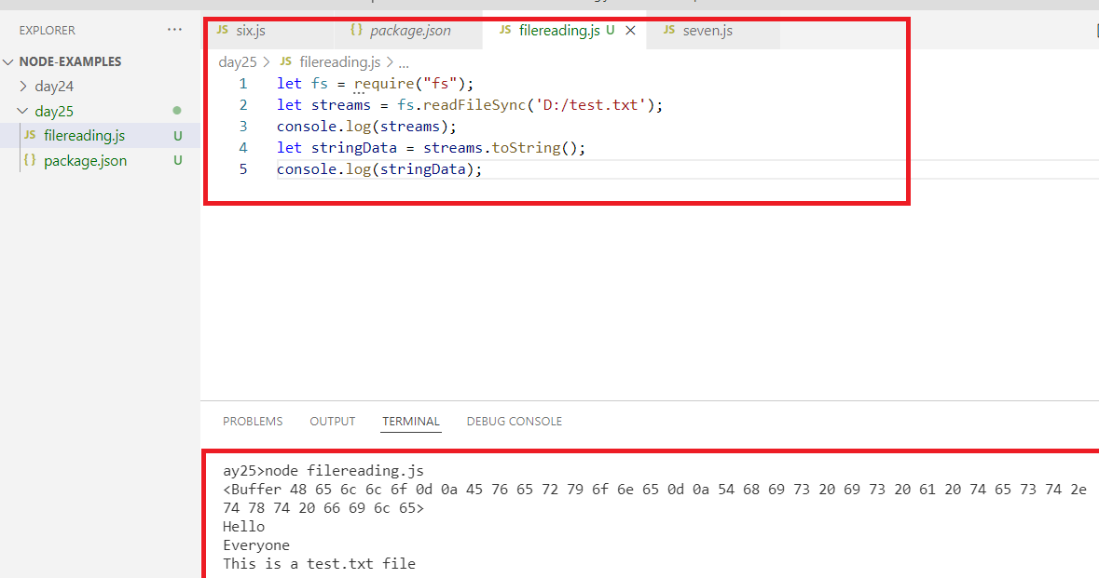

Writing data to the file

Whenever you are writing the data into the file it must be in string format or text format, if you have other type of data it must be converted to string, ex: if you have Javascript object then you can’t store them in the file, it must be converted to text like JSON and store as a JSON data later when you read you get JSON that can be converted back to javascript object.

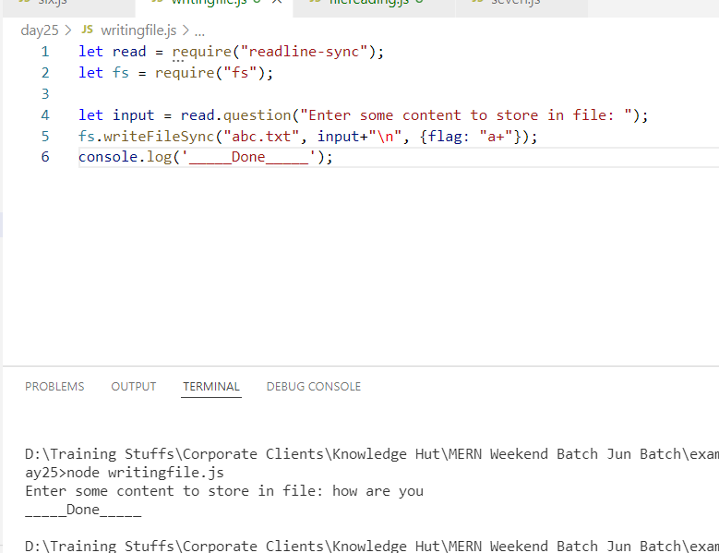

Suppose you want to store a Javascript object or multiple javascript objects, then its necessary that you store in a JSON file by converting Javascript object to JSON using

JSON.stringify(javascriptObject): This converts Javascript to JSON string

JSON.parse(jsonString): This converts JSON string to Javascript object

Note: You can convert array of Javascript objects also as JSON string it will be created as JSON array

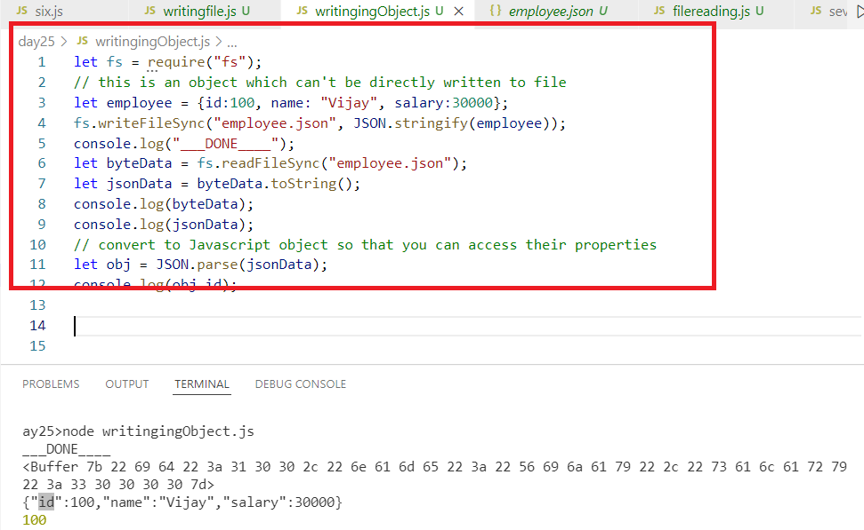

How to maintain multiple Javascript objects in the file

1. You need to first have all the javascript objects in the array & convert that array to JSON which becomes JSON array, like a container of multiple JOSN data, you need to convert Javascript array to JSON array using JSON.strigify(javascriptObjectArray)
2. When you read the JSON array you can convert to Javascript array using JSON.parse(jsonString)

The JSON file will have all the JSON data in a [] which is a container to store multiple JSON data

writingArray.js

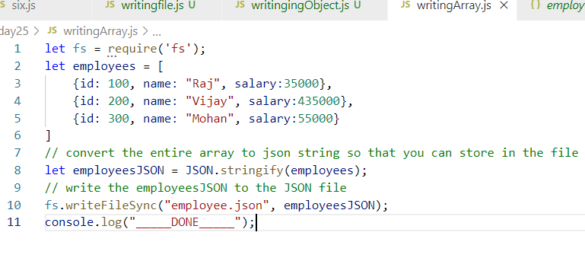

If you want to add the JSON inside the array again, you don’t have to append, we must read this array first and then convert to javascript array & push the new javascript object and convert it back to JSON and write in the file

Activity

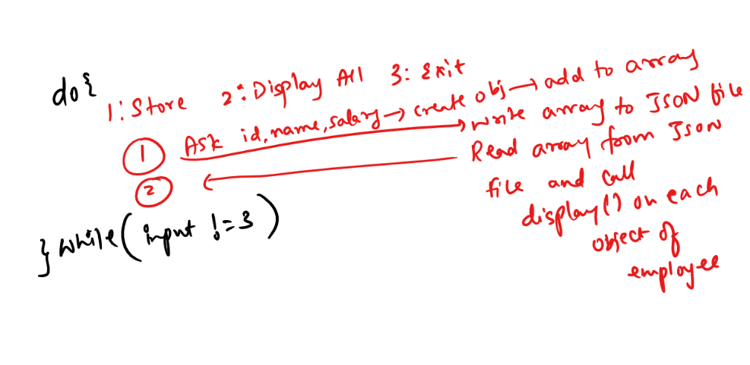

Node.js web application

It is used to handle requests from the client & generate response, node.js provides http module which is a core module that helps you to create a server instance and handle request from the client and generate response to the client.

let http = require(‘http’);

// create a server instance

let server = http.createServer( (request, response) => { ….. } );

the callback in the createServer, must take 2 arguments mandatorily 1st argument can handle request & 2nd argument must be used to generate response, this callback is executed when the client sends request.

// start the server

server.port(port_number, () => { …. } );

The above statement starts the server in particular port and runs the callback when the server starts

Note: the 2 arguments of callback in createServer can have any names like req or r in place of request, it is a common practice to use request, so that developers can understand that they are working in which object

main.js

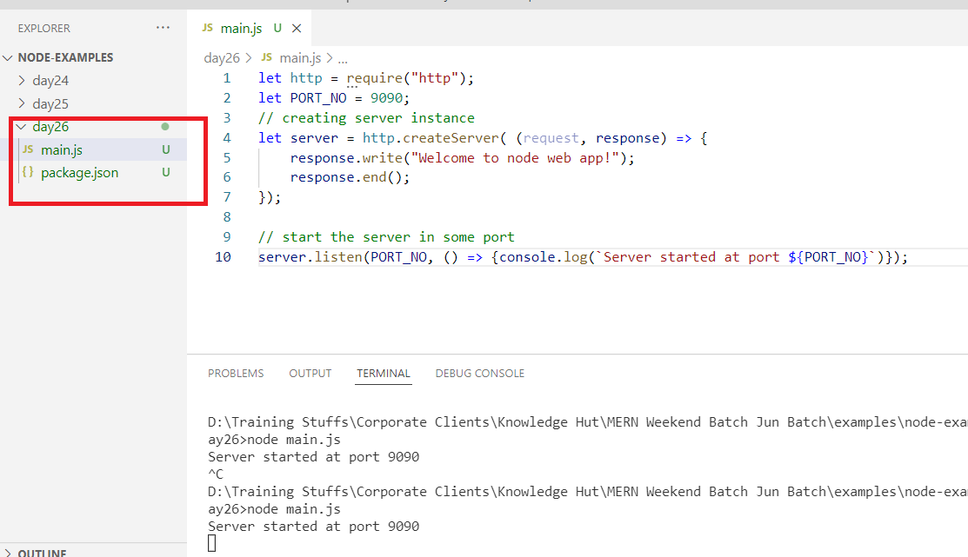

Output:

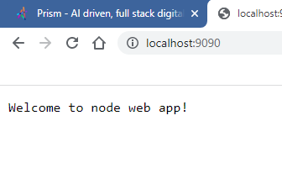

Note: Use Control + C to stop the server

Note: The server once starts can’t detect any changes of the application until the next restart, hence you can use nodemon library to run your web application which can detect the changes in the application

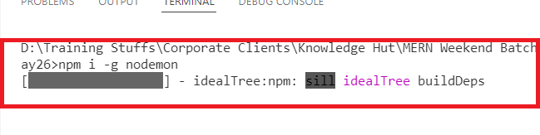

Once nodemon is installed you can use nodemon to run your javascript instead of node because it can detect the changes in the application while its running.

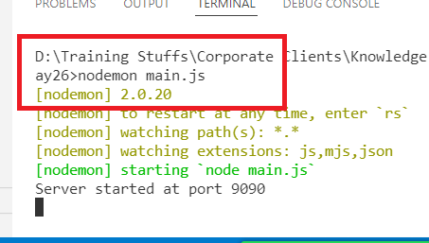

By default the content of the response is treated as text, since these contents are shown by browser we can embed the HTML tags in this text, however the browser don’t understand it as HTML element instead it shows the tag as it is because the entire content is treated as text.

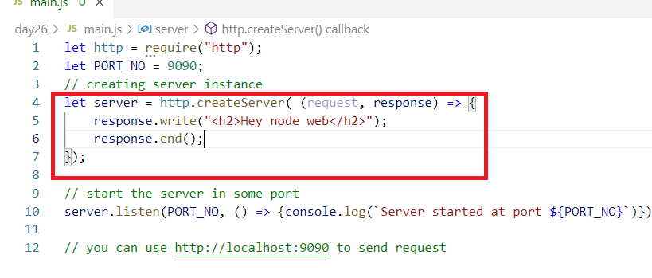

Since the text is rendered in the browser we want <h2> to be interpreted by browser, but browser doesn’t do that as it is a text.

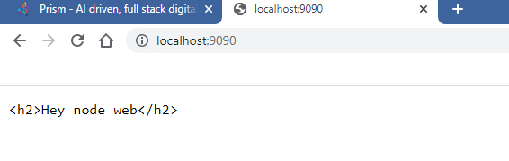

Some browsers may detect these as <h2> element but some not, hence you can use content-type: ‘text/html’ property in the response header.

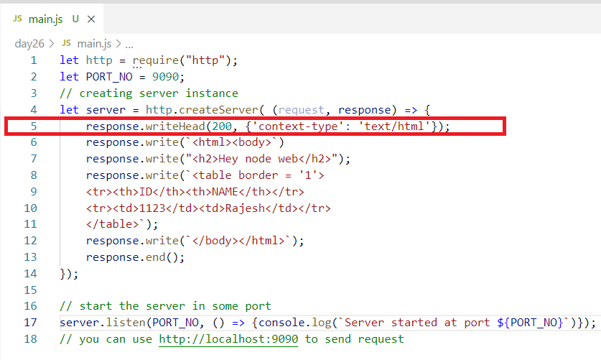

Output:

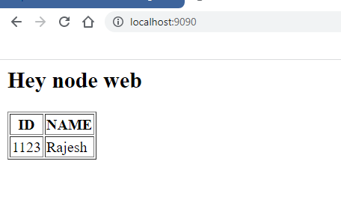

We also have some data in the server & send to the client in HTML format

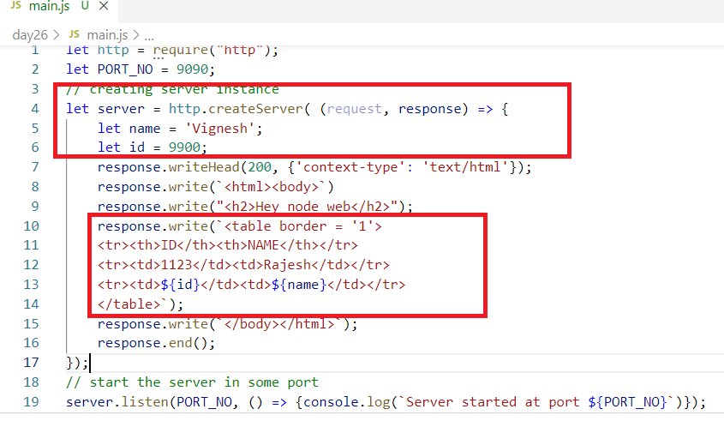

Output:

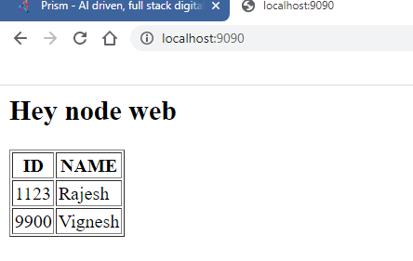

url module

it is a module that helps to parse the URL and convert to URL object, this URL object will have a property called query using that you can extract the query parameters

You can first parse the query using

let url = require(‘url’);

let object = url.parse(request.url);

let query = object.query; // this returns the query parameters in javascript object form

you can use query.property to extract the query parameters which you sent in the request url

i.e.,

if request.url = <http://localhost:9090?name=Ajay&age=35>

Then url.parse(request.url) returns an object with a property called

query = {name:”Ajay”, age:35}

query.name returns Ajay

query.age returns 35

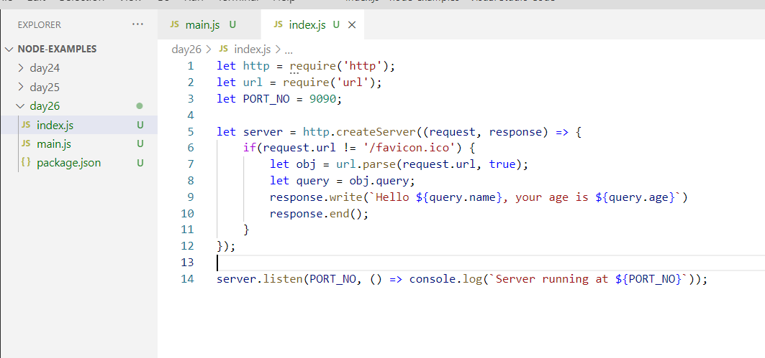

Output:

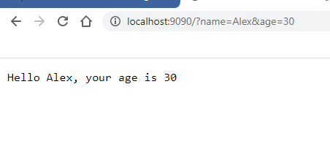

We can always use this query parameter to search any records in the backend database or file systems.

Reading the records from JSON by passing input from the client through query parameter

users.json

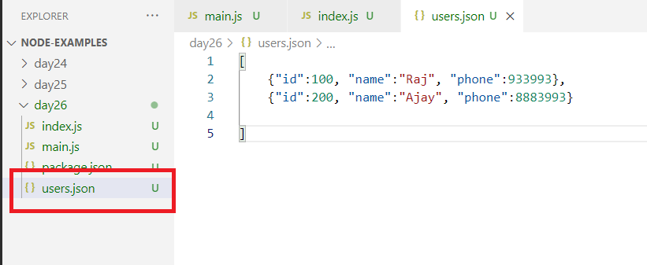

index.js

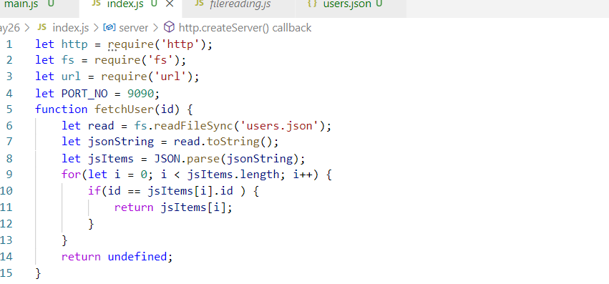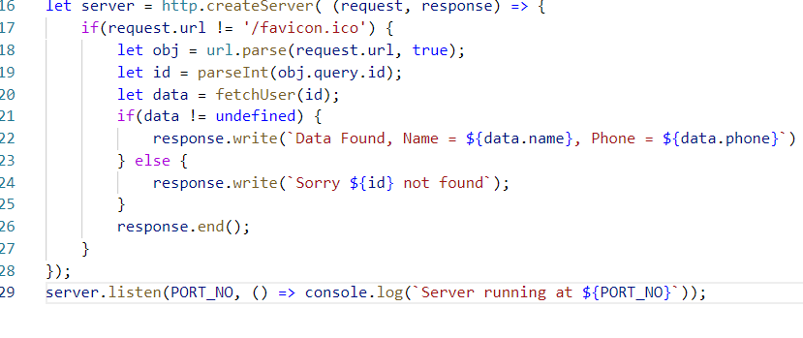

Output:

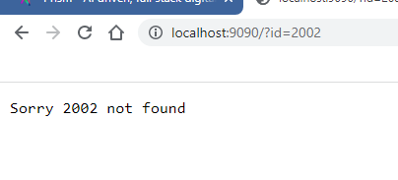

ReSTful Webservices

ReSTful stands for Representational State Transfer.

Representational: Structure like JSON/XML/TEXT

State: Data

Transfer: To communicate

Webservices are online services which helps different applications to exchange the data in a common format that can be converted to the format the applications can understand, example If the common format is JSON then the end application can convert JSON to Java if its written in Java, if its written in Javascript then it can be converted to Javascript.

Since webservices are consumed by different types of applications there should be some principles both webservices & consumers need to follow like

URL: Webservice url that consumers can use to access so that the corresponding function mapped to this URL is executed

HTTP method: To specify what operation the webservice is performing and also what operation consumers wants to do, there’re 4 methods of HTTP you can use based on your operations like

* POST: Storing
* GET: Retrieving
* PUT: Updating
* DELETE: Deleting

Since you can create webservices using any technology you can use node.js with express.js module in Javascript to create webservices

Express Module

It is a module used in the node.js to create ReST based webservices which is not inbuilt, you need to download it

Since we can’t test the webservices we created in all the languages, we can use postman application to test the webservice.

Installing express module

npm install express --save

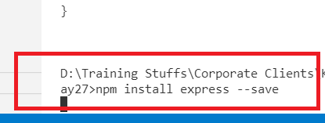

app.js

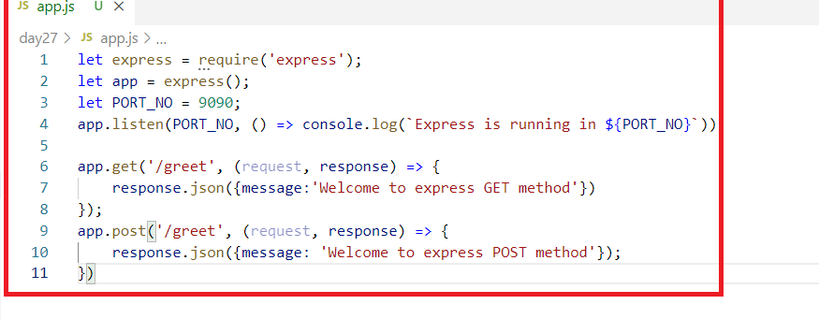

Output:

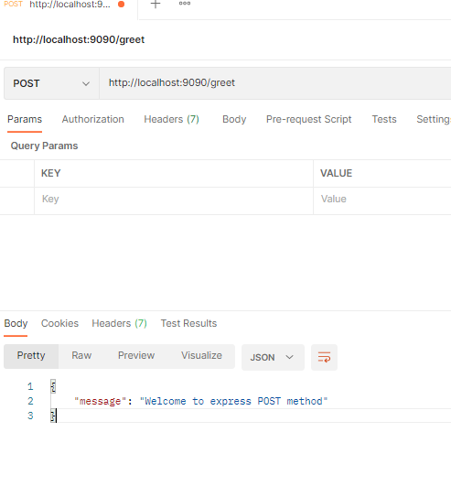

We can also respond data with Text as well

response.send(textContent);

We sometimes need to return the response with different status codes like 200, 404 and so on in that case you can use response.status(code).json(…);

Webservices with different status code in the response

Whenever client sends a request to the webservice it expects whether request is successful or failed, it can recognize it using the status of the response like 2XX, 4XX, hence we must always have a webservice that atleast returns the response with 2xx & 4xx.

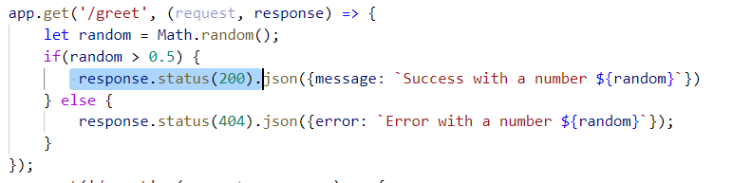

Passing data to the webservice from the client

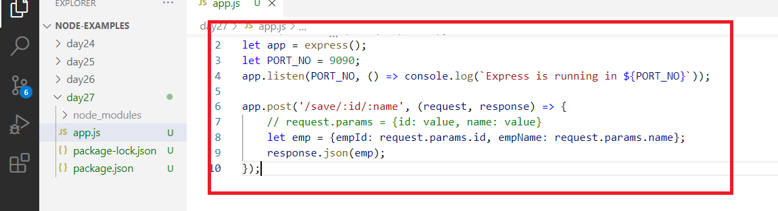

Output:

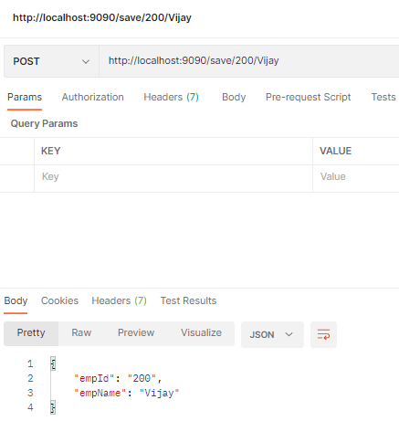

Sending JSON data from the consumer to the webservice

Here the consumer may be sending more data while making a request, in that case it can send the data in the request body in JSON format the webservice needs to use request.body to extract the data in the body, because the body will have json data it must be parsed so that the JSON will be converted to Javascript.

We need here two libraries

1. express: To create REST API’s
2. body-parser: To parse the request body so that if the request body has json it will be converted to javascript object.

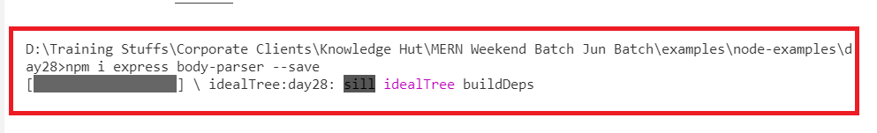

app.js

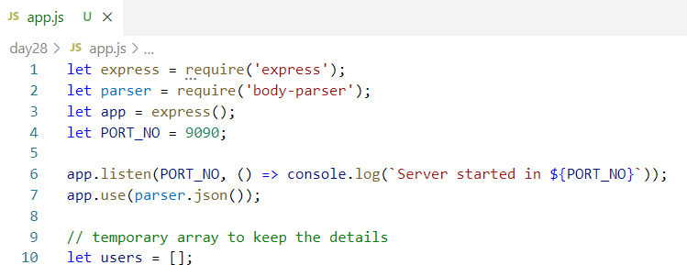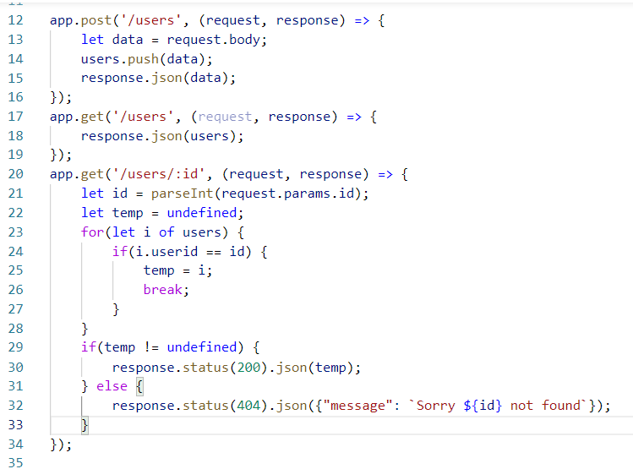

Output:

Sending post request that stores users in array till the application reloads

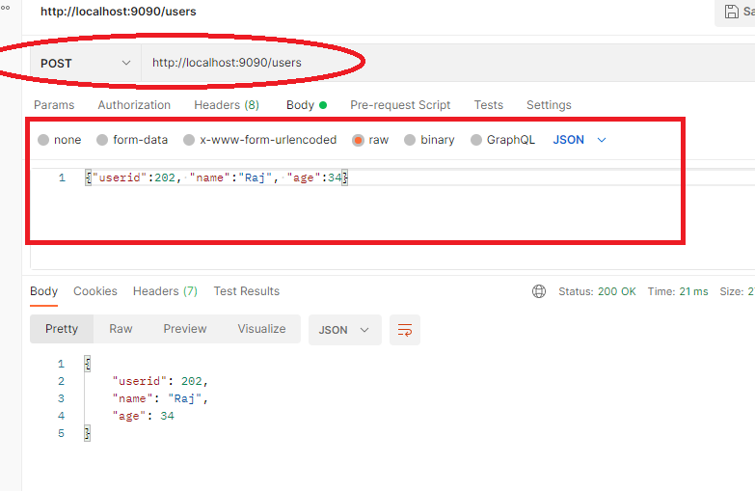

Sending get request to fetch all records

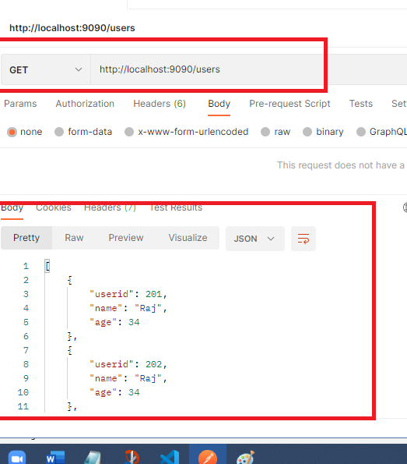

Get request with id

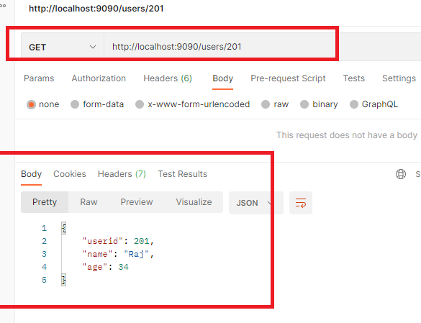

GET request if the id doesn’t exist

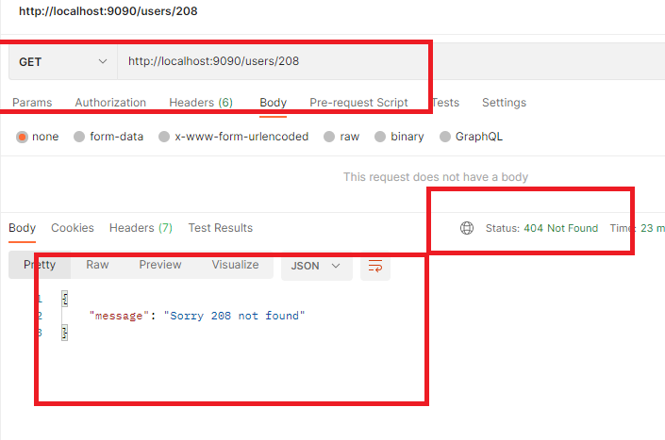

MongoDB:

It is a open-source No-SQL database, which stores the records in JSON format which are called as documents, the documents can have any structure, but it must have one field mandatorily i.e., _id which is to recognize the uniqueness of the documents

ex:

You can have all these documents in one container which is called as collection

Collection: It is a container like a table to keep all the documents

mongodb commands

mongod: this is used to start the database server, it will search for data/db folder in the location where you entered mongod

mongo: this is used to enter mongodb queries to perform CRUD operations

Note: Your terminal may not recognise these commands, hence you need to set the path of the mongod & mongo.

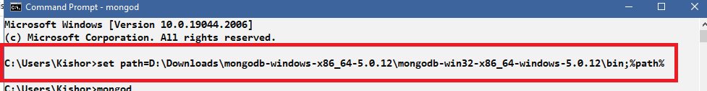

Now you can enter mongo & mongod commands

But you must create data/db in the parent folder from where you are launching mongod command

>> mongod

Ensure data/db is created else you get error.

MongoDB is a No-SQL database, which means non-structured database which stores the data as a document in the collection.

No Structure means the documents can have any kind of structure and one document structure need not be same as another document structure.

MongoDB stores the data in JSON format which is called as document, these documents are stored in collections

MongoDB provides two commands from the /bin folder

1. mongod: This is used to start the database
2. mongo: This is used to enter inside mongo shell which helps you to enter mongo commands to perform CRUD operations.

List of mongodb commands

Creating Database/Switching to the database

use database_name; # this will create a new database and switches to the database

ex: use mydb;

Creating Collection

db.createCollection(“name”); # this creates a collection with the name you specify

ex: db.createCollection(“employee”);

Inserting a document inside a collection

db.collectionName.insertOne( { js-object}); # this inserts a document, by default _id is created with is unique for each document, else we can also pass the _id

ex: db.employee.insertOne({_id: 100, name: “Raj”, salary: 35200});

Inserting Multiple documents

db.collectionName.insertMany( [ { js-object }, { js-object}, ..] ); # this inserts multiple documents, if _id is not supplied it creates an unique _id for each document

ex: db.employee.insertMany( [ { _id:101, name: “Rahul”, salary: 45200}, {_id:200, name: “Raj”, salary: 50000}, {… }, …. ]);

Note: Mongodb commands are case sensitive, you must use insertOne, insertMany and all other commands as it is, if in case you use insertone then mongodb doesn’t recognize it

Retrieving the documents

db.collectionName.find(); # this returns all the documents in the collection

ex: db.employee.find();

Retrieving the particular document

db.collectionName.find(<condition>); # this returns the document which matches to the condition, you must write the condition in javascript object form

ex: db.employee.find( { _id: 100 }); # this returns the enter document that has _id = 100

ex: db.employee.find ( { name: “Raj” } ); # this returns all the documents that has name = “Raj”

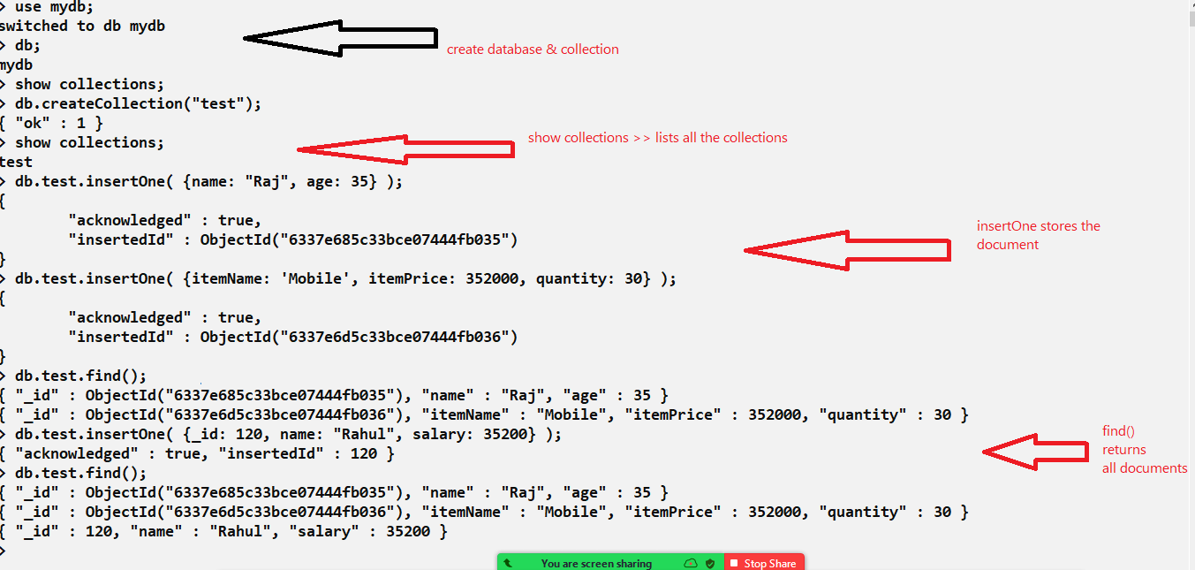

Finding records based on conditions

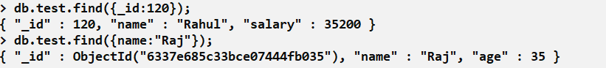

Insert Many Records

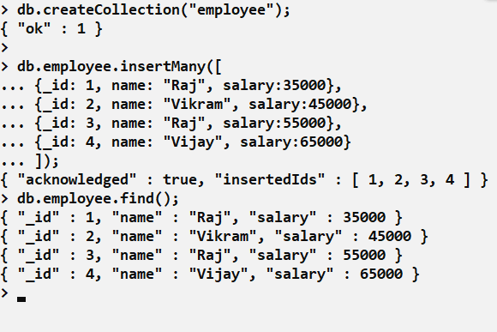

Using $and, $or operators to apply multiple conditions

db.collectionName.find( { $and: [ {object}, {object} ] });

db.collectionName.find( { $or: [ {object}, {object} ] });

ex:

db.employee.find( { $and: [ {name:”Raj”}, { salary: 55000} ] } );

db.employee.find( { $or: [ {name:”Raj”}, { salary: 45000} ] } );

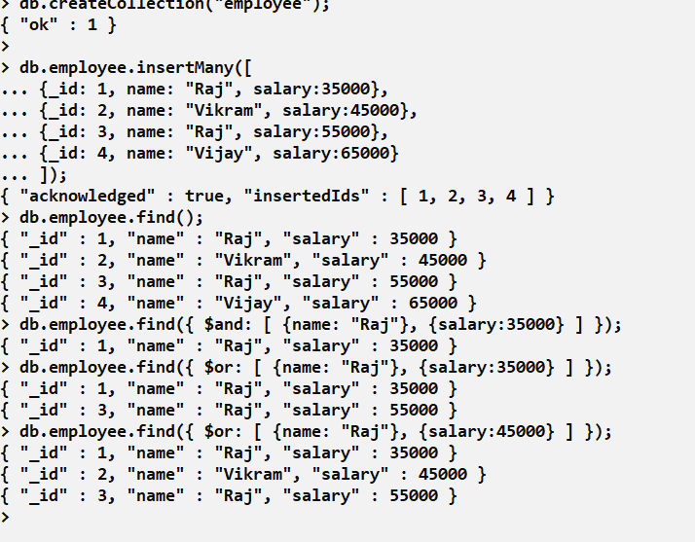

apart from these we have $lte, $gte, $gt, $lt, $in, $eq and so on

$lte: it is used to apply condition which is having the value less than equal

db.employee.find({salary: {$lte: 40000});

$gte: for greater than equal

db.employee.find( { salary: { $gte: 50000} } );

$in: When you want any one in the list of values to be matched

db.employee.find( { salary: { $in: [30000, 40000, 45000] }} );

$eq: When you want value to match exactly be equal

db.employee.find( { salary: { $eq: 35000} } )

Auto-increment the _id in mongodb

Mongodb doesn’t have any keywords like other RDBMS supports to auto_increment, in Mongodb you need to create some javascript function and store it in the system.js file so that the function will be always available for you to auto_increment values, this script will have a function that can increment the values.

What happens if you create function in the terminal

It will be temporary which is erased once the terminal is closed, hence you need to create a system.js file in your db so that the functions can be used even after closing the terminal.

Steps:

1. You need to create a collection that can store the current sequence value
2. You need to create a function that can query the collection having the sequence & update that collection so that it can return the next sequence value
3. When you want to store the sequence in your collection then, you can call the function to get the next sequence value & store it in your document

Creating a collection that maintains the current sequence

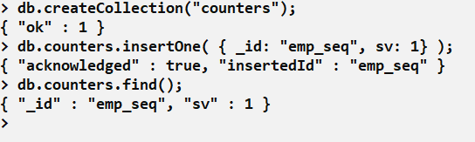

Creating a function that queries this sequence and modifies it to the next sequence and returns it

You need to create a Javascript function that can query the sequence, modify the current sequence to return the next sequence number.

function empSeq() {   
 let updateDoc = db.counters.findAndModify({  
 query: {_id: “emp_seq”},  
 update: { $inc: {sv: 1} },  
 new: true  
 });  
 return updateDoc.sv;  
};

Now you can call the function empSeq() each time you want a new sequence

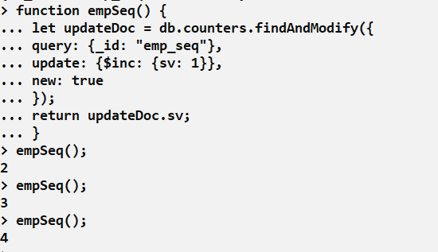

Now we need to call this function at the time inserting the document

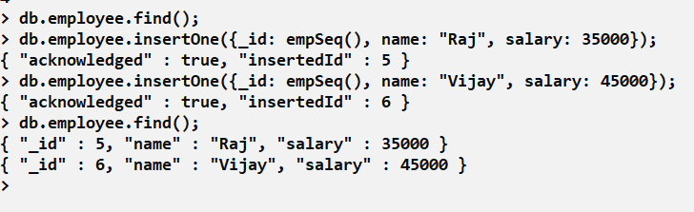

Note: The above sequence function is not permanent, it will be erased once you close terminal

How to keep the sequence functions stored permanently in mongodb

We must create the function inside a script file called system.js, which can be loaded when you start the terminal so that the function will be available.

system.js: it is the default file used to load any scripts or functions that needs to be used in the terminal

Note: db.loadServerScripts(); is the function that automatically loads the system.js file in the terminal.

Creating a script that stores in system.js, which can be loaded when we open terminal

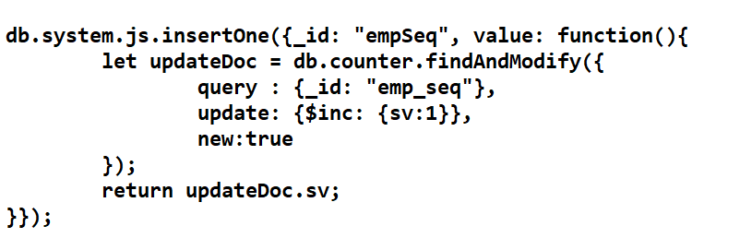

Running the script in the terminal

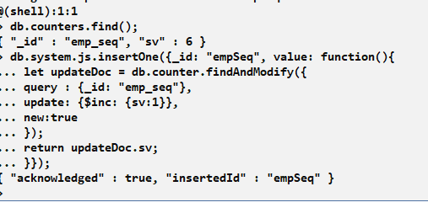

Loading the script using db.loadServerScripts()

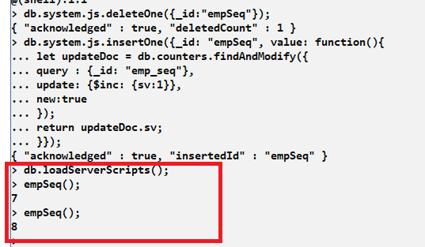

Note: You need to run the db.loadServerScripts() each time you want to use any function present in it.

deleteOne & deleteMany

These are used to delete one or more documents based on the condition, deleteOne() deletes only one record in the collection i.e., first record which is found, deleteMany deletes all the records that is matching to the condition.

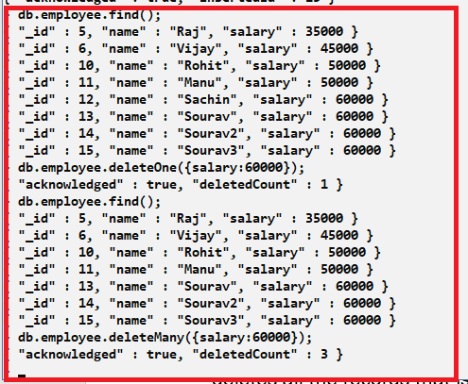

updateOne & updateMany  
updateOne updates very first record that is found based on the condition, however updateMany updates many records that is found based on the condition, you must use $set to update the property.

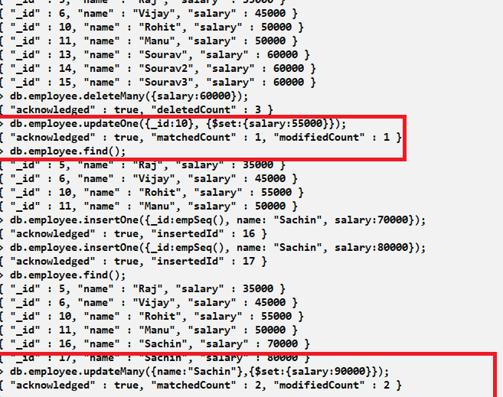

Important things to know in MongoDB

* insertOne & insertMany
* findOne & find
* deleteOne & deleteMany
* updateOne & updateMany

Node.js provides mongodb library to interact with the mongodb database

We can create ReST endpoints using express.js and perform CRUD operations on MongoDB using mongodb library.

Libraries required

1. mongodb: provides functions like findOne(), insertOne(), deleteOne() and so on.
2. express
3. body-parser
4. cors: it is used to accept request from another domain, it is necessary when react interacts with express.js, it is not required if you are testing webservices using postman

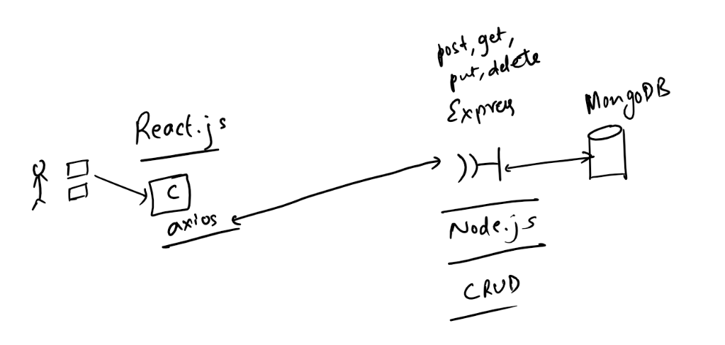

Create a new collection called users that can maintain _id, name, password, phone

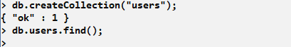

Create package.json and install express, body-parser, cors, mongodb libraries

package.json

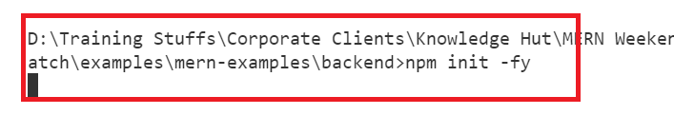

Installing libraries

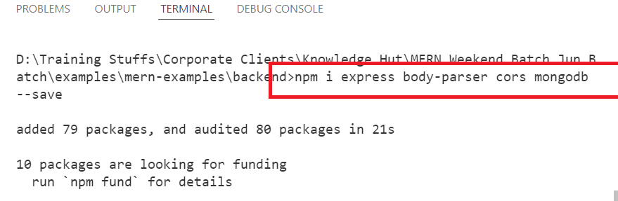

Express code needs to use mongodb url to connect, the mongodb library provides methods to perform CRUD operations

Steps to interact with mongodb

Importing MongoClient which connects to the DB

let mongoClient = require(“mongodb”).MongoClient;

Using mongodb url

let url = “mongodb://localhost:27017”;

Connecting to the mongodb using mongoClient & url from the method connect

mongoClient.connect(url, {useNewUrlParser : true}, callback(error, client) {   
 // here we must do the CRUD operations  
} );

Callback has 2 arguments error & client, if the connection is success then client should be used to interact with the DB, if connection fails then error is passed

app.js

